# Spring Certification Module 3 – Data Management

# Question 01 - What is the difference between checked and unchecked exceptions? Why does Spring prefer unchecked exceptions? What is the data access exception hierarchy?

Unchecked exception – Exception that is extending java.lang.RuntimeException class, does not have to be explicitly declared in throws part of method signature of method that is throwing an exception and does not have to be explicitly handled by code that invokes the method. Developer has freedom of choice if error handling should be implemented or not.

Pros:

*  Reduces cluttered code
*  Reduces coupling between callee and caller

Cons:

*  May result in missing situations in which error handling should be implemented
*  Lack of compile-time feedback on error handling

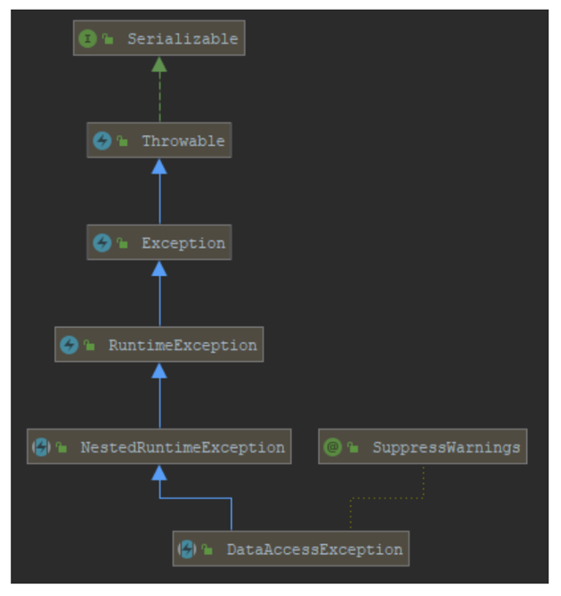

* Data Access Exception is a Runtime Exception
*  Examples of concrete Data Access Exceptions
*  CannotAcquireLockException
*  CannotCreateRecordException
*  DataIntegrityViolationException
*  Purpose of this hierarchy is to create abstraction layer on top of Data Access APIs to avoid coupling with concrete implementation of Data Access APIs

# Question 02 - How do you configure a DataSource in Spring? Which bean is very useful for development/test databases?

Data Source is represented by generic interface javax.sql.DataSource which represent any data source for sql database.

To configure data source in Spring you need to create a @Configuration class that will return javax.sql.DataSource bean.

You can use for example following types of javax.sql.DataSource:

*  DriverManagerDataSource – basic JDBC driver connection source
*  BasicDataSource – Apache DBCP for Connection Pooling
*  ComboPooledDataSource - C3P0 for Connection Pool
*  SmartDataSource
*  AbstractDataSource
*  SingleConnectionDataSource
*  TransactionAwareDataSourceProxy
*  DataSourceTransactionManager

Configuration of Data Source in Spring is dependent on type of application that is executed.

Type of execution:

*  Standalone – Data Source is configured in @Configuration class and is created as a bean of one of supported data source types
*  Spring Boot – Data Source is configured through application.properties data.sql and schema.sql uploaded automatically.
*  Application Server – Data Source should be fetched from JNDI via JndiDataSourceLookup / JndiTemplate, application server is responsible for creating and managing data source requested in resources
* configurations of deployment descriptors

When working with development/test databases, following beans are very useful:

*  EmbeddedDatabaseBuilder – allows to easily configure H2/HSQLDB embedded database with schema/data initialization scripts
*  DataSourceInitializer / ResourceDatabasePopulator – allows to use schema/data initialization scripts without usage of EmbeddedDatabaseBuilder

## 2.1 Stand Alone

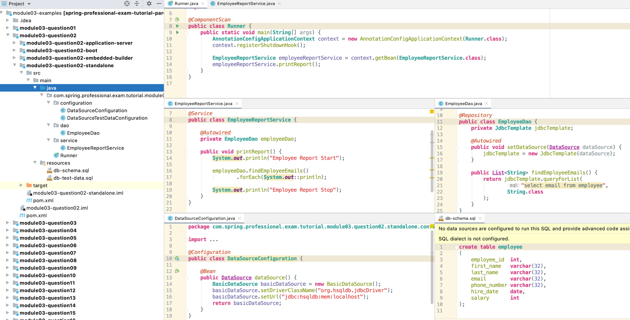

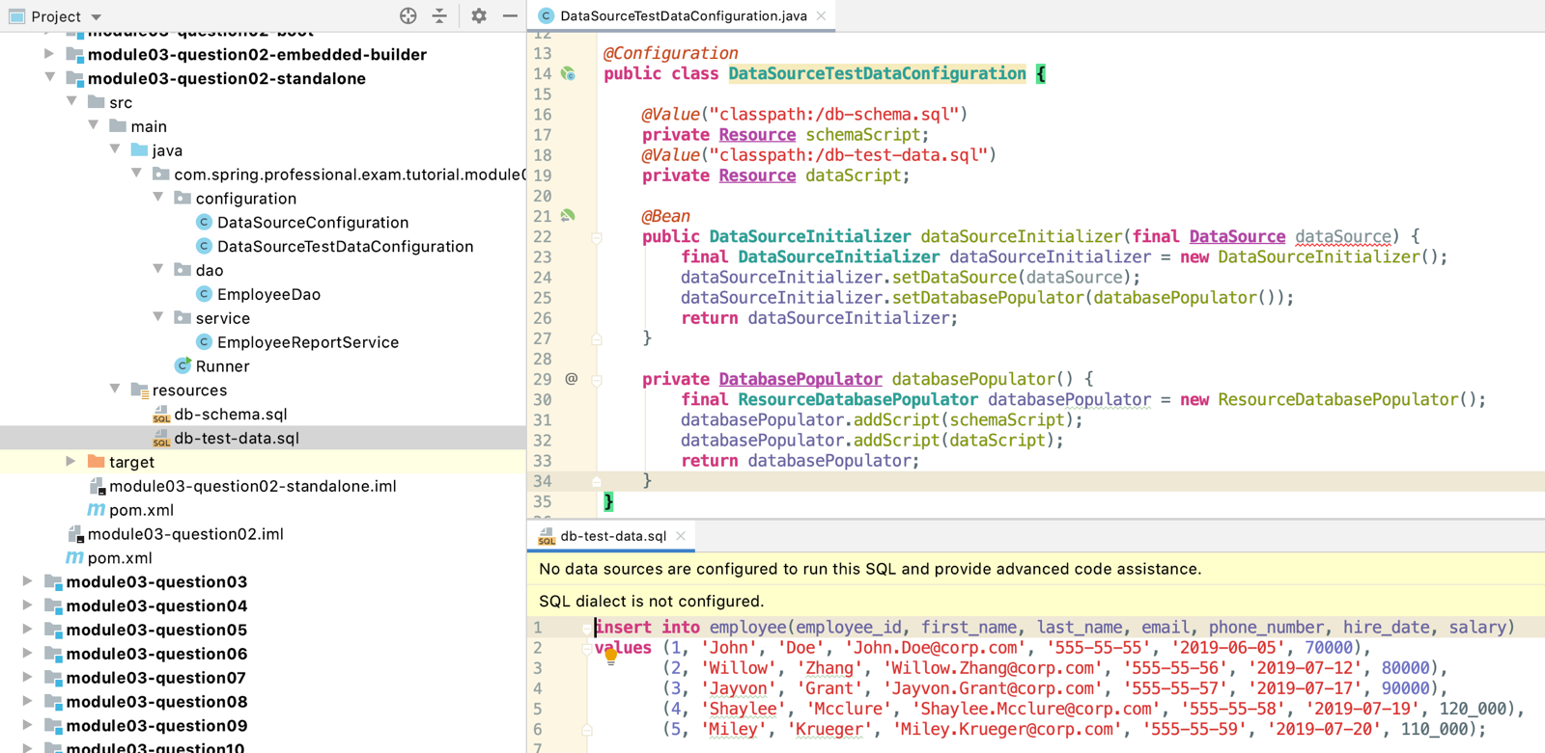

## 2.2 SpringBoot

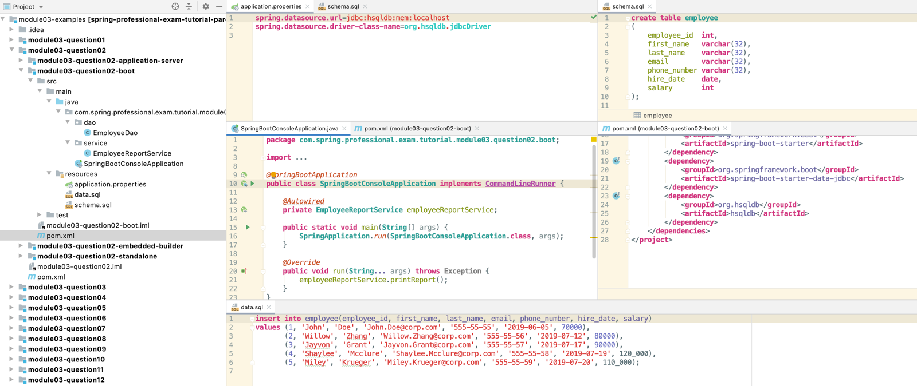

## 2.3 Application Server

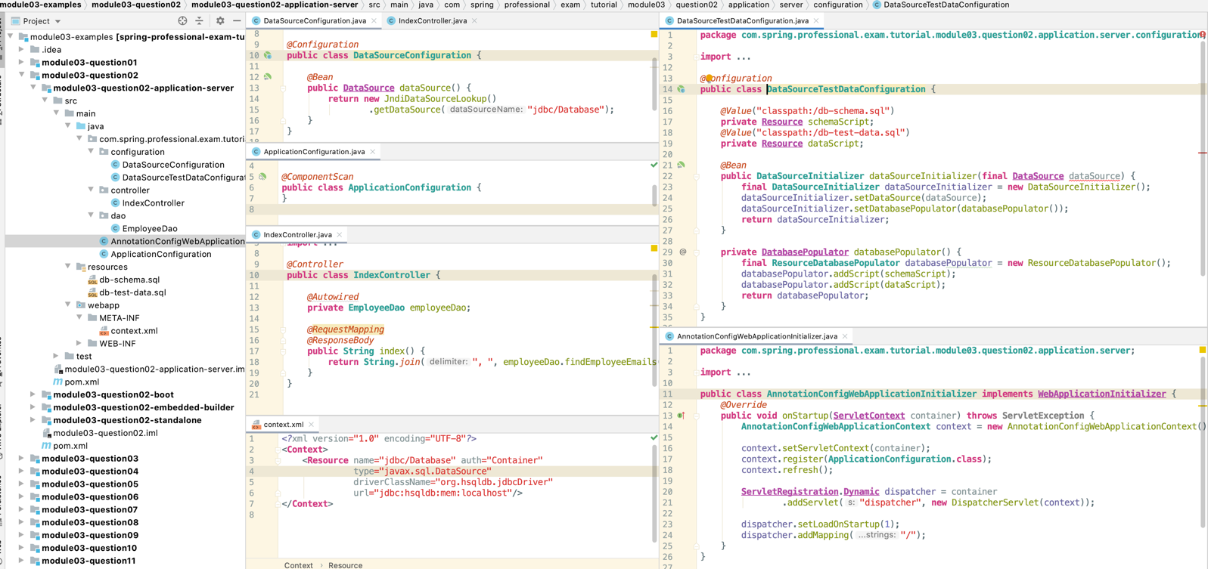

## 2.4 Embedded-Builder – Integration Test

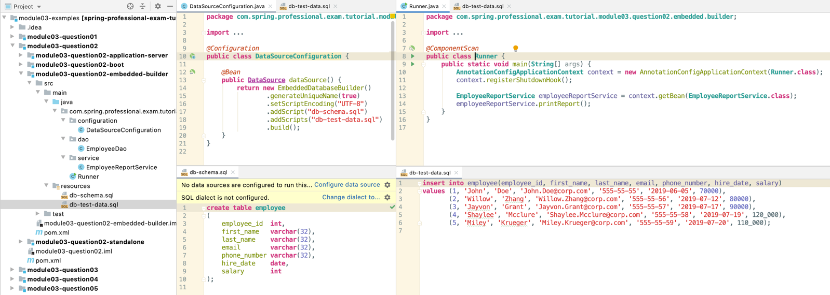

# Question 03 - How do you configure a DataSource in Spring? Which bean is very useful for development/test databases?

Template design pattern is a behavioral design pattern that can be used to encapsulate algorithm/main flow with it steps in a way to achieve steps customization and shared code reusability. It is achieved by creating abstract class that contains algorithm definition/main flow with shared code, and child classes extending abstract class which are customizing step or steps of the algorithm.

Template design pattern can be used to achieve greater code reusability, **however** since it is using inheritance, which is very strong relationship between classes it can limit future flexibility of the system. You should use this pattern with caution and you should analyze if strategy design pattern will not give you similar results. Strategy uses composition instead of inheritance and in some cases instead of using template method, strategy can be used to achieve code reusability and also code flexibility.

Below you can find class diagram for report subsystem written with usage of template design pattern.

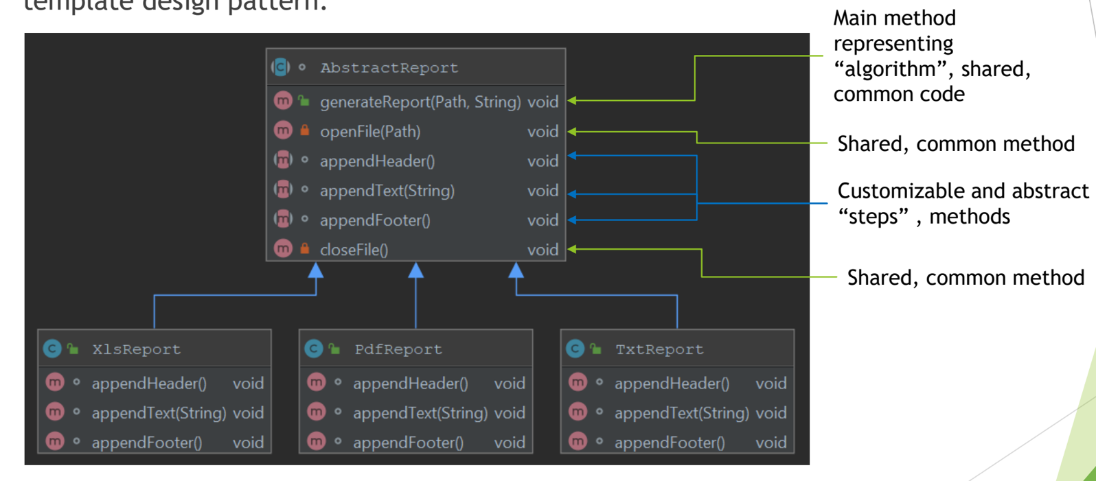

JdbcTemplate is a class located in org.springframework.jdbc.corepackage. Goal of this class is to simplify use of JDBC by providing implementation of JDBC workflow, leaving application to provide SQL statements and results extractions.

JdbcTemplateexecutes SQLqueriesorupdates,initiatesiterationover ResultSet, ResultSetmapping, alsoitcatchesexceptionsandtranslatesthemintogenericexceptions.

Code that interacts with JdbcTemplate needs to provide implementation of callback interfaces which allows specific steps of JDBC workflow customization:

* PreparedStatementCreator
* ResultSetExtractor
* PreparedStatementSetter
* RowMapper

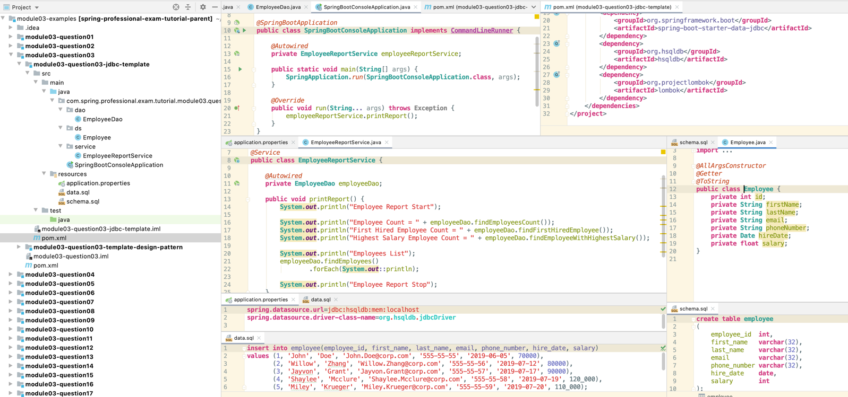

*@Repository***public class EmployeeDao** {  
 **private JdbcTemplate** jdbcTemplate;  
  
 *@Autowired* **public void** setDataSource(**DataSource** dataSource) {  
 jdbcTemplate = **new** JdbcTemplate(dataSource);  
 }  
  
 **public List**<**Employee**> findEmployees() {  
 **return** jdbcTemplate.query(  
 "select employee_id, first_name, last_name, email, phone_number, hire_date, salary from employee",  
 **this**::mapEmployee  
 );  
 }  
  
 **public Employee** findFirstHiredEmployee() {  
 **return** jdbcTemplate.queryForObject(  
 "select * from employee order by hire_date limit 1",  
 **this**::mapEmployee  
 );  
 }  
  
 **public Employee** findEmployeeWithHighestSalary() {  
 **return** jdbcTemplate.queryForObject(  
 "select * from employee order by salary desc limit 1",  
 **this**::mapEmployee  
 );  
 }  
  
 **public int** findEmployeesCount() {  
 **return** jdbcTemplate.queryForObject(  
 "select count(*) from employee",  
 **Integer**.**class** );  
 }  
  
 *@SneakyThrows* **private Employee** mapEmployee(**ResultSet** resultSet, **int** i) {  
 **return new** Employee(  
 resultSet.getInt("employee_id"),  
 resultSet.getString("first_name"),  
 resultSet.getString("last_name"),  
 resultSet.getString("email"),  
 resultSet.getString("phone_number"),  
 resultSet.getDate("hire_date"),  
 resultSet.getFloat("salary")  
 );  
 }  
}

# Question 04 - How do you configure a DataSource in Spring? Which bean is very useful for development/test databases?

## 4.1 Lamdas

A callback is a code or reference to the code that can be passed as an argument to the method. This method will execute passed callback during execution.

On Java level callback can be:

* Class that implements interface
* Anonymous class
* Lambda expression –JDK 8
* Reference Method –JDK 8

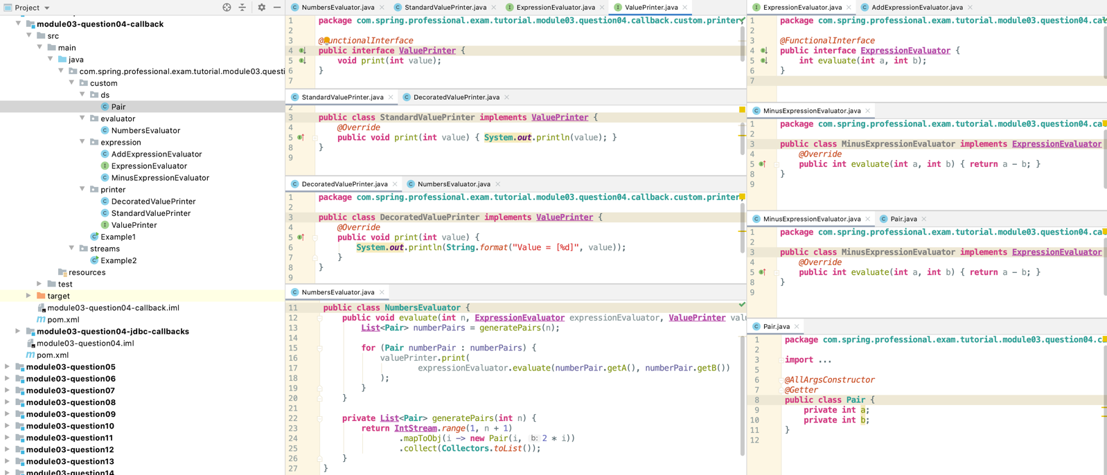

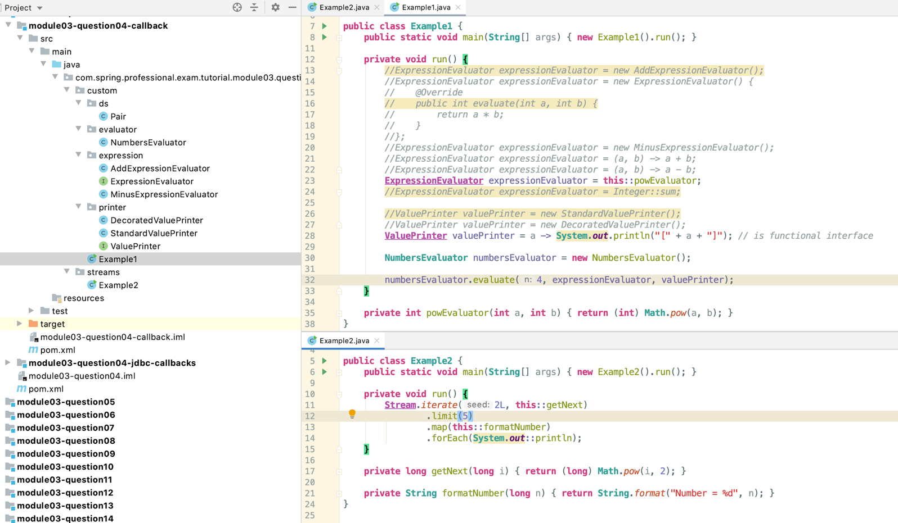

## 4.2 Jdbc

Template Callbacks that can be used with queries:

*  RowMapper interface for processing ResultSet data on per row basis, implementation should call ResultSet.get *(..) methods, but should not call ResultSet.next ()(), it should only extract values from current row and based on those values should create object, which will be returned from mapRow method, implementation is usually stateless
  + **public List**<**Employee**> findEmployees() {  
     **return** jdbcTemplate.query(  
     "select employee_id, first_name, last_name, email, phone_number, hire_date, salary from employee",  
     **new RowMapper**<**Employee**>() { *// this can be a lambda  
     @Override* **public Employee** mapRow(**ResultSet** resultSet, **int** rowNum) **throws SQLException** {  
     **return new** Employee(  
     resultSet.getInt("employee_id"),  
     resultSet.getString("first_name"),  
     resultSet.getString("last_name"),  
     resultSet.getString("email"),  
     resultSet.getString("phone_number"),  
     resultSet.getDate("hire_date"),  
     resultSet.getFloat("salary")  
     );  
     }  
     }  
     );  
    }
*  RowCallbackHandler interface for processing ResultSet data on a per row basis, implementation should call ResultSet.get *(..) methods, but should not call ResultSet.next ()(), it should only extract values from current row, implementation is usually stateful, it keeps accumulated data in some object, processRow method from this class does not return any value, instead method saves results into for example object field that will keep state
  + **public float** findAverageSalaryRowByRow() {  
     **AverageSalaryRowCallbackHandler** averageSalaryRowCallbackHandler = **new** AverageSalaryRowCallbackHandler();  
      
     jdbcTemplate.query(  
     "select salary from employee",  
     averageSalaryRowCallbackHandler  
     );  
      
     **return** averageSalaryRowCallbackHandler.getAverageSalary();  
    }
  + **private static class AverageSalaryRowCallbackHandler implements RowCallbackHandler** {  
     **private float** salarySum = 0;  
     **private int** salariesCount = 0;  
      
     *@Override* **public void** processRow(**ResultSet** rs) **throws SQLException** {  
     salarySum += rs.getFloat("salary");  
     ++salariesCount;  
     }  
      
     **public float** getAverageSalary() {  
     **return** salarySum / (**float**) salariesCount;  
     }  
    }
*  ResultSetExtractor interface for processing entire ResultSet data, all rows needs to be processed and implementation should call ResultSet.next method to move between rows, implementation is usually stateless, implementation should not close ResultSet , it will be closed by Jdbc Template
  + **public Float** findAverageSalaryCalculatedOnEntireResultSet() {  
     **return** jdbcTemplate.query(  
     "select salary from employee",  
     **new** AverageSalaryResultSetExtractor()  
     );  
    }  
    **private static class AverageSalaryResultSetExtractor implements ResultSetExtractor**<**Float**> {  
     *@Override* **public Float** extractData(**ResultSet** rs) **throws SQLException**, **DataAccessException** {  
     **float** salarySum = 0;  
     **int** salariesCount = 0;  
      
     **while** (rs.next()) {  
     salarySum += rs.getFloat("salary");  
     ++salariesCount;  
     }  
      
     **return** salarySum / (**float**) salariesCount;  
     }  
    }
  + **public double** findAverageSalaryModernImplementation() {  
     **return** jdbcTemplate.queryForList(  
     "select salary from employee",  
     **Double**.**class** ).stream()  
     .mapToDouble(**Double**::*valueOf*)  
     .average()  
     .orElse(0f);  
    }
  + **public double** findAverageSalarySqlLevel() {  
     **return** jdbcTemplate.queryForObject(  
     "select avg(salary) from employee",  
     **Double**.**class** );  
    }
* PreparedStatementCreator–should create PreparedStatementbased on Connectionprovided by JdbcTemplate, implementation should provide SQL and parameters
* PreparedStatementSetter–should set values on PreparedStatementprovided by JdbcTemplate, implementation should only set parameters, SQL will be set by JdbcTemplate
* CallableStatementCreator–should create CallableStatementbased on Connectionprovided by JdbcTemplate, implementation should provide SQL and parameters
  + **public int** findEmployeeIdFromEmail(**String** email) {  
     **return** jdbcTemplate.query(  
     **new PreparedStatementCreator**() {  
     *@Override* **public PreparedStatement** createPreparedStatement(**Connection** con) **throws SQLException** {  
     **return** con.prepareStatement("select employee_id from employee where email = ?");  
     }  
     },  
     **new PreparedStatementSetter**() {  
     *@Override* **public void** setValues(**PreparedStatement** ps) **throws SQLException** {  
     ps.setString(1, email);  
     }  
     },  
     **new ResultSetExtractor**<**Integer**>() {  
     *@Override* **public Integer** extractData(**ResultSet** rs) **throws SQLException**, **DataAccessException** {  
     **if** (rs.next())  
     **return** rs.getInt("employee_id");  
     **else  
     throw new** SQLException("Unable to find id based on email");  
     }  
     }  
     );  
    }
* PreparedStatementCallback–used internallyby JdbcTemplate–generic interface allowing number of operations on single PreparedStatement
* CallableStatementCallback–used internally by JdbcTemplate–generic interface allowing number of operations on single CallableStatement

# Question 05-Can you execute a plain SQL statement with the JDBC template?

Yes, JDBC Template allows execution of plain SQL statements with following methods:

* query
* queryForList
* queryForObject
* queryForMap
* queryForRowSet
* execute
* update
* batchUpdate

*@Repository***public class EmployeeDao** {  
 **private JdbcTemplate** jdbcTemplate;  
  
 *@Autowired* **public void** setDataSource(**DataSource** dataSource) {  
 jdbcTemplate = **new** JdbcTemplate(dataSource);  
 }  
  
 **public List**<**Employee**> findEmployees() {  
 **return** jdbcTemplate.query(  
 "select employee_id, first_name, last_name, email, phone_number, hire_date, salary from employee",  
 **this**::mapEmployee  
 );  
 }  
  
 **public List**<**String**> findEmployeesEmails() {  
 **return** jdbcTemplate.queryForList("select email from employee", **String**.**class**);  
 }  
  
 **public Employee** findEmployeeWithHighestSalary() {  
 **return** jdbcTemplate.queryForObject(  
 "select employee_id, first_name, last_name, email, phone_number, hire_date, salary from employee order by **salary** desc limit 1",  
 **this**::mapEmployee  
 );  
 }  
  
 **public Employee** findEmployeeById(**Integer** id) {  
 **return** jdbcTemplate.queryForObject(  
 "select employee_id, first_name, last_name, email, phone_number, hire_date, salary from employee where employee_id = ?",  
 **new** Object[]{id},  
 **this**::mapEmployee  
 );  
 }  
  
 **public Map**<**String**, **Object**> findEmployeeThatWasHiredLast() {  
 **return** jdbcTemplate.queryForMap(  
 "select employee_id, first_name, last_name, email, phone_number, hire_date, salary from employee order by **hire_date** limit 1"  
 );  
 }  
  
 **public SqlRowSet** findEmployeesEmailsAndPhones() {  
 **return** jdbcTemplate.queryForRowSet(  
 "select email, phone_number from employee"  
 );  
 }  
  
 **public void** insertNewDummyRecord() {  
 jdbcTemplate.execute(  
 "insert into employee values(999, 'Dummy', 'Dummy', 'Dummy.Dummy@dummy.com', '111-11-11', '2019-06-05', 1)"  
 );  
 }  
  
 **public int** updateDummyRecord(**Integer** id, **String** firstName) {  
 **return** jdbcTemplate.update(  
 "update employee set first_name = ? where employee_id = ?",  
 **new** Object[]{firstName, id}  
 );  
 }  
  
 **public int**[] updateRecordsWithDummyData() {  
 **return** jdbcTemplate.batchUpdate(  
 "update employee set first_name = 'AAA' where employee_id = 1",  
 "update employee set first_name = 'BBB' where employee_id = 2",  
 "update employee set first_name = 'CCC' where employee_id = 3"  
 );  
 }  
  
 *@SneakyThrows* **private Employee** mapEmployee(**ResultSet** resultSet, **int** i) {  
 **return new** Employee(  
 resultSet.getInt("employee_id"),  
 resultSet.getString("first_name"),  
 resultSet.getString("last_name"),  
 resultSet.getString("email"),  
 resultSet.getString("phone_number"),  
 resultSet.getDate("hire_date"),  
 resultSet.getFloat("salary")  
 );  
 }  
}

# Question 06 -When does the JDBC template acquire (and release) a connection, for every method called or once per template? Why?

Connection lifecycle in JDBC Template depends on transactions being involved or not.

If JDBC Template is used without transaction, then connection is acquired and released for every method call. Reason for this strategy, is to minimize amount of time when resource (connection) has to be held.

If JDBC Template is used together with transaction, then DataSourceUtils which is using TransactionSynchronizationManager will reuse connection between method calls as long as transaction is not committed or rolled back. Reason for this strategy is that connection cannot be closed when transaction is in progress, since closing connection would also rollback any changes made.

JDBC Template uses getConnection()method from DataSource class through DataSourceUtils class. If DataSource is plain JDBC Connection source, then connection is actually opened/closed, however if Connection Pool, like DBCP or C3P0 is used, then connection is not being opened/closed, however it is acquired or released from/to the pool.

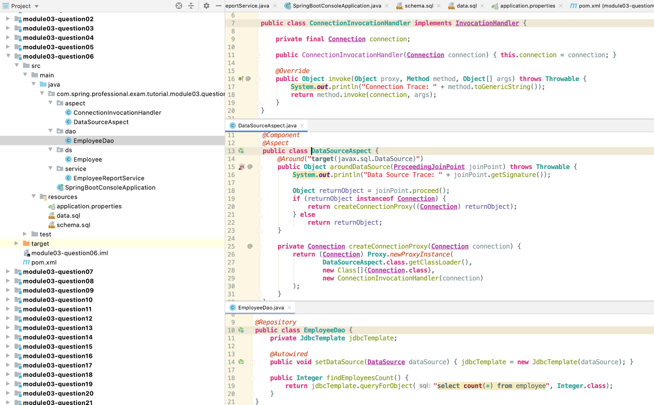

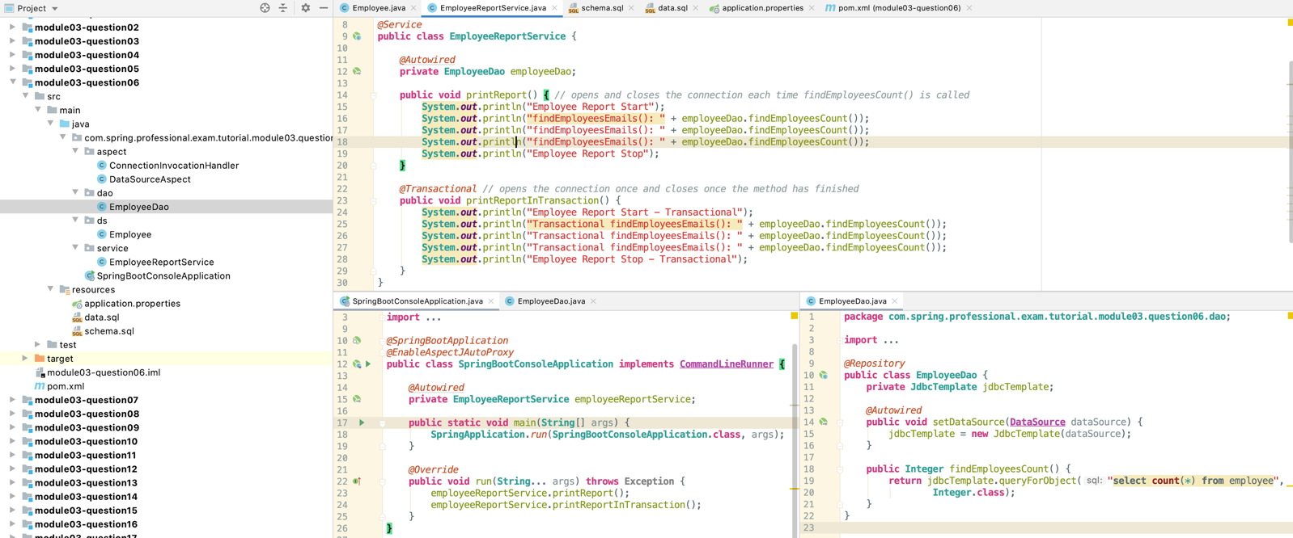

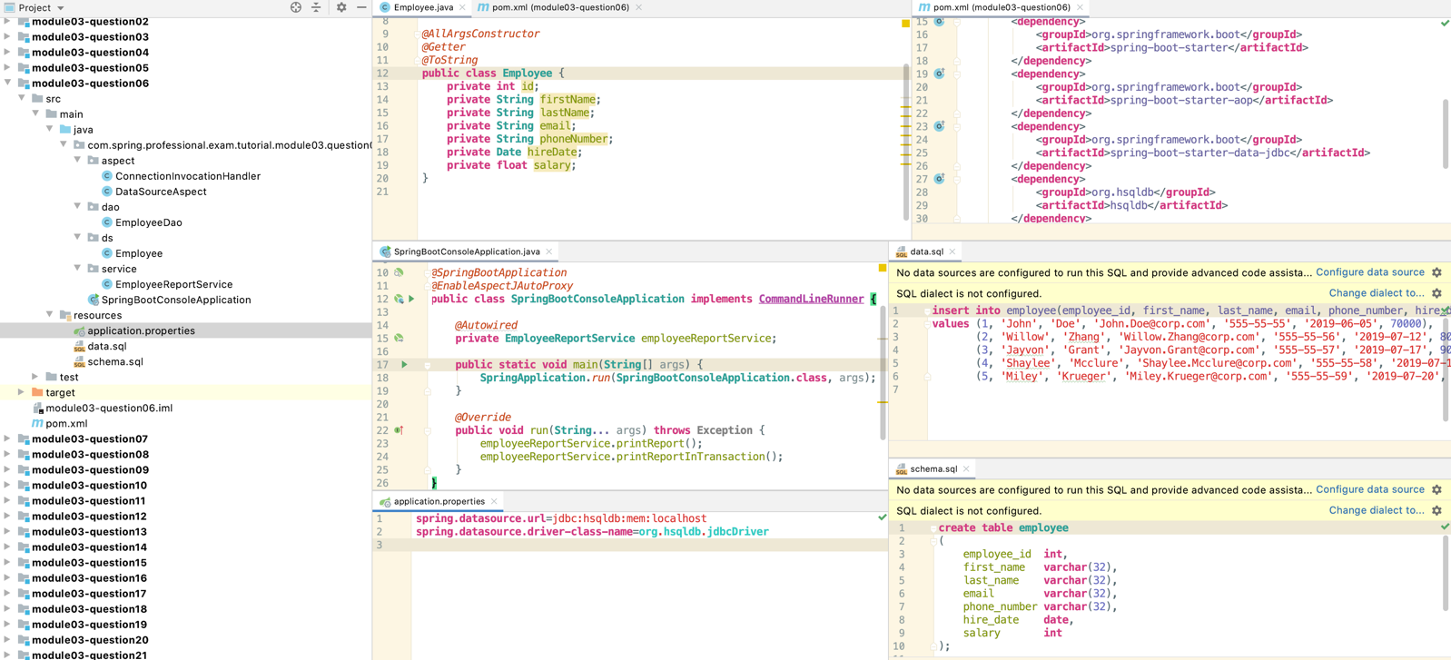

# Question 07 -How does the JdbcTemplate support generic queries? How does it return objects and lists/maps of objects?

Jdbc Template supports generic queries with following methods:

* queryForObject –returns single object, expects query to return only one record, if this requirement is not matched IncorrectResultSizeDataAccessExceptionwill be thrown
* queryForList –returns list of objects of declared type, expects query to return results with only one column, otherwise IncorrectResultSetColumnCountExceptionwill be thrown
* queryForMap –returns map for single row with keys representing column names and values representing database record value, expects query to return only one record, if this requirement is not matched IncorrectResultSizeDataAccessExceptionwill be thrown
* queryForRowSet–returns SqlRowSetobject that contains metadata information (like column names) and allows to read results data and iterate through records

All of the methods above have many versions, allowing you to specify not only query itself, but also parameters to the query and customer row mapper if required.

Jdbc Template returns objects, lists/map by using following:

* objects –queryForObject –SingleColumnRowMapperfor generic types and RowMapperfor custom types
* lists –queryForList –SingleColumnRowMapper for generic types
* maps –queryForMap–ColumnMapRowMapper for any query

*@Repository***public class EmployeeDao** {  
 **private JdbcTemplate** jdbcTemplate;  
  
 *@Autowired* **public void** setDataSource(**DataSource** dataSource) {  
 jdbcTemplate = **new** JdbcTemplate(dataSource);  
 }  
  
 **public String** findEmployeeEmail(**int** id) { *//John.Doe@corp.com* **return** jdbcTemplate.queryForObject("select email from employee where employee_id = ?", **new** Object[]{id}, **String**.**class**);  
 }  
  
 **public List**<**String**> findEmployeesNames() { *//John Willow Jayvon Shaylee Miley* **return** jdbcTemplate.queryForList("select first_name from employee", **String**.**class**);  
 }  
  
 **public Map**<**String**, **Object**> findEmployeeById(**int** id) {  
 *//{EMPLOYEE_ID=2, FIRST_NAME=Willow, LAST_NAME=Zhang, EMAIL=Willow.Zhang@corp.com, PHONE_NUMBER=555-55-56, HIRE_DATE=2019-07-12, SALARY=80000}* **return** jdbcTemplate.queryForMap("select * from employee where employee_id = ?", id);  
 }  
  
 **public SqlRowSet** findEmployeesRowSet() {  
 **return** jdbcTemplate.queryForRowSet("select * from employee");  
 }  
 */* EMPLOYEE_ID,FIRST_NAME,LAST_NAME,EMAIL,PHONE_NUMBER,HIRE_DATE,SALARY  
1,John,Doe,John.Doe@corp.com,555-55-55,2019-06-05,70000  
2,Willow,Zhang,Willow.Zhang@corp.com,555-55-56,2019-07-12,80000  
3,Jayvon,Grant,Jayvon.Grant@corp.com,555-55-57,2019-07-17,90000  
4,Shaylee,Mcclure,Shaylee.Mcclure@corp.com,555-55-58,2019-07-19,120000  
5,Miley,Krueger,Miley.Krueger@corp.com,555-55-59,2019-07-20,110000  
} */* **public Employee** findEmployee(**int** id) {  
 *// Employee(id=2, firstName=Willow, lastName=Zhang, email=Willow.Zhang@corp.com, phoneNumber=555-55-56, hireDate=2019-07-12, salary=80000.0)* **return** jdbcTemplate.queryForObject("select employee_id, first_name, last_name, email, phone_number, hire_date, salary from employee where employee_id = ?", **new** Object[]{id}, **this**::mapEmployee);  
 }  
  
 **public List**<**Employee**> findAllEmployees() {  
 *//[Employee(id=1, firstName=John, lastName=Doe, email=John.Doe@corp.com, phoneNumber=555-55-55, hireDate=2019-06-05, salary=70000.0), Employee(id=2, firstName=Willow,...* **return** jdbcTemplate.query("select employee_id, first_name, last_name, email, phone_number, hire_date, salary from employee", **this**::mapEmployee);  
 }  
  
 *@SneakyThrows* **private Employee** mapEmployee(**ResultSet** resultSet, **int** i) {  
 **return new** Employee(  
 resultSet.getInt("employee_id"),  
 resultSet.getString("first_name"),  
 resultSet.getString("last_name"),  
 resultSet.getString("email"),  
 resultSet.getString("phone_number"),  
 resultSet.getDate("hire_date"),  
 resultSet.getFloat("salary")  
 );  
 }  
}

*@AllArgsConstructor  
@Getter  
@ToString***public class Employee** {  
 **private int** id;  
 **private String** firstName;  
 **private String** lastName;  
 **private String** email;  
 **private String** phoneNumber;  
 **private Date** hireDate;  
 **private float** salary;  
}

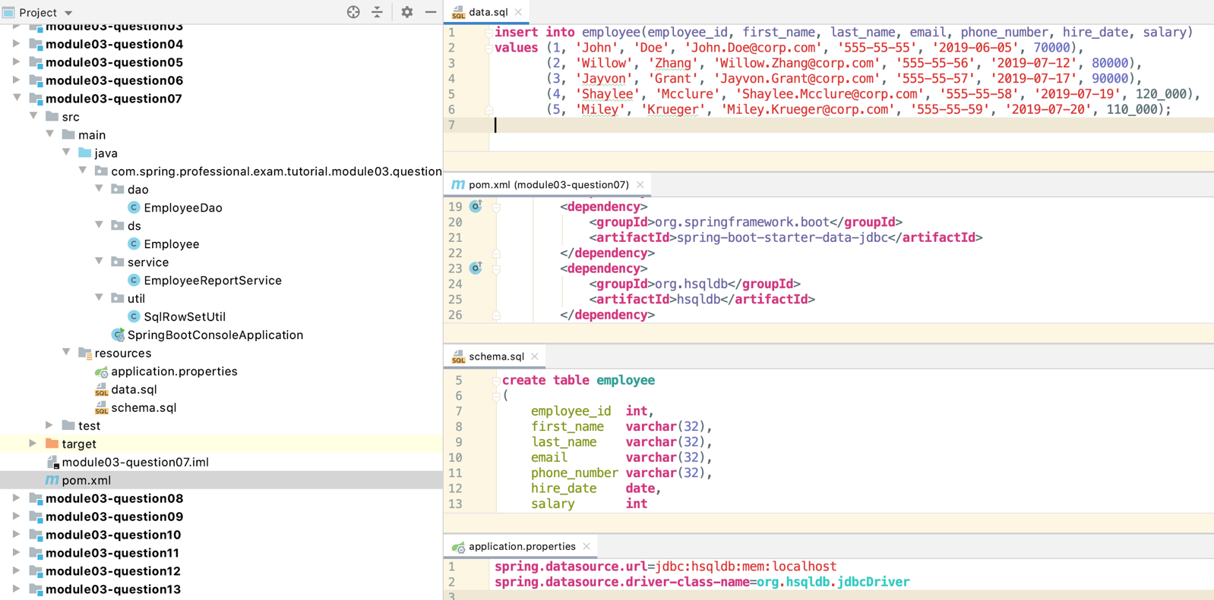

Question 08 -What is a transaction? What is the difference between a local and a global transaction?

Transaction is an operation that consist of series of tasks, in which all of those tasks should be performed, or none of the tasks should be performed. Those tasks are being treated as one unit of work. If all tasks in transaction are successful, changes made by those tasks are preserved, if at least one of the tasks is unsuccessful, changes made by tasks that were already completed will be reverted and any tasks awaiting execution will no be executed.

Transaction should follow ACID principle:

* Atomicity –All changes are applied or no changes are applied
* Consistency –system should go from one valid state to other valid state, any constraints on data should never be left in invalid state
* Isolation –one transaction cannot affect other one, concurrent execution of transaction should leave system in the same state as if sequential execution of transaction would be performed
* Durability –guarantees that if transaction has been committed, data will be preserved, even in case of system/power failure

Global transaction is a kind of transaction that spans multiple transactional resources. Those resources can be anything, but usually include databases (can be more then one) and queues. In Java, popular standard for managing global transaction is JTA, which is an API for using transaction system provided by Application Server.

Local transaction are resource specific transaction, they do not span across multiple transactional resources. Local transactions are much simpler than global transaction however main disadvantages is lack of ability to treat series of tasks dealing with multiple transactional resources such as databases or databases and queues as single unit of work.

*@SpringBootApplication***public class SpringBootConsoleApplication implements CommandLineRunner** {  
  
 *@Autowired* **private EmployeesService** employeesService;  
  
 **public static void** main(**String**[] args) {  
 **SpringApplication**.*run*(**SpringBootConsoleApplication**.**class**, args);  
 }  
  
 *@Override* **public void** run(**String**... args) **throws Exception** {  
 **try** {  
 employeesService.saveEmployeesWithoutTransaction();  
 } **catch** (**Exception** e) {  
 **System**.***out***.println("Exception during saving employees: " + e.getMessage());  
 }  
 employeesService.printEmployees();  
 employeesService.deleteAllEmployees();  
  
 **try** {  
 employeesService.saveEmployeesInTransaction();  
 } **catch** (**Exception** e) {  
 **System**.***out***.println("Exception during saving employees: " + e.getMessage());  
 }  
 employeesService.printEmployees();  
 employeesService.deleteAllEmployees();  
 }  
}

*@Service***public class EmployeesService** {  
  
 *@Autowired* **private EmployeeDao** employeeDao;  
  
 **public void** printEmployees() {  
 **System**.***out***.println("Printing list of employees");  
 employeeDao.findAllEmployees().forEach(**System**.***out***::println);  
 }  
  
 **public void** deleteAllEmployees() {  
 **System**.***out***.println("Deleting all employees...");  
 employeeDao.deleteAllEmployees();  
 }  
  
 **public void** saveEmployeesWithoutTransaction() { *// will save all employees up until the exception is thrown - doesn't rollback* **System**.***out***.println("Saving employees without transaction...");  
 saveEmployees();  
 }  
  
 *@Transactional //if one operation fails all teh operations will be reverted ACID* **public void** saveEmployeesInTransaction() {  
 **System**.***out***.println("Saving employees with transaction...");  
 saveEmployees();  
 }  
  
 **private void** saveEmployees() {  
 employeeDao.saveEmployee(**new** Employee(1, "John", "Doe", "John.Doe@corp.com", "555-55-55", **Date**.*valueOf*("2019-06-05"), 70000));  
 employeeDao.saveEmployee(**new** Employee(2, "Willow", "Zhang", "Willow.Zhang@corp.com", "555-55-56", **Date**.*valueOf*("2019-07-12"), 80000));  
 employeeDao.saveEmployee(**new** Employee(3, "Jayvon", "Grant", "Jayvon.Grant@corp.com", "555-55-57", **Date**.*valueOf*("2019-07-17"), 90000));  
 employeeDao.saveEmployee(**new** Employee(-1, "Shaylee", "Mcclure", "Shaylee.Mcclure@corp.com", "555-55-58", **Date**.*valueOf*("2019-07-19"), 120000));  
 employeeDao.saveEmployee(**new** Employee(5, "Miley", "Krueger", "Miley.Krueger@corp.com", "555-55-59", **Date**.*valueOf*("2019-07-20"), 110000));  
 }  
}

*@Repository***public class EmployeeDao** {  
 **private JdbcTemplate** jdbcTemplate;  
  
 *@Autowired* **public void** setDataSource(**DataSource** dataSource) {  
 jdbcTemplate = **new** JdbcTemplate(dataSource);  
 }  
  
 **public List**<**Employee**> findAllEmployees() {  
 **return** jdbcTemplate.query("select employee_id, first_name, last_name, email, phone_number, hire_date, salary from employee", **this**::mapEmployee);  
 }  
  
 **public void** deleteAllEmployees() {  
 **int** numberOfDeletedRows = jdbcTemplate.update("delete from employee");  
  
 **System**.***out***.println(**String**.*format*("Employees deleted, number of deleted rows = [%d]", numberOfDeletedRows));  
 }  
  
 **public void** saveEmployee(**Employee** employee) {  
 **if** (employee.getId() < 0)  
 **throw new** IllegalArgumentException("Employee Id has to be greater than zero");  
  
 **int** numberOfRecordsInserted = jdbcTemplate.update(  
 "insert into employee(employee_id, first_name, last_name, email, phone_number, hire_date, salary) " +  
 "values (?, ?, ?, ?, ?, ?, ?)",  
 employee.getId(),  
 employee.getFirstName(),  
 employee.getLastName(),  
 employee.getEmail(),  
 employee.getPhoneNumber(),  
 employee.getHireDate(),  
 employee.getSalary()  
 );  
  
 **if** (numberOfRecordsInserted == 1)  
 **System**.***out***.println(**String**.*format*("Saved employee [%d]", employee.getId()));  
 **else  
 throw new** IllegalStateException(**String**.*format*("Expected 1 record to be inserted, instead retrieved [%d] number of records inserted", numberOfRecordsInserted));  
 }  
  
 *@SneakyThrows* **private Employee** mapEmployee(**ResultSet** resultSet, **int** i) {  
 **return new** Employee(  
 resultSet.getInt("employee_id"),  
 resultSet.getString("first_name"),  
 resultSet.getString("last_name"),  
 resultSet.getString("email"),  
 resultSet.getString("phone_number"),  
 resultSet.getDate("hire_date"),  
 resultSet.getFloat("salary")  
 );  
 }  
}

# Question 09-Is a transaction a cross cutting concern? How is it implemented by Spring?

Transaction is a cross cutting concern and in Spring it is implemented with usage of @Transactional annotation.

If @Transactionalannotation is present on top of the method or entire class, then each call to the method in the class will be proxied by TransactionInterceptor and TransactionAspectSupport classes. Those classes will interact with PlatformTransactionManager to commit transaction upon successful method execution or rollback upon exception. Exact behaviour will be dependent on transaction propagation and isolation level settings, which can be set in @Transactional annotation.

# Question 10 -How are you going to define a transaction in Spring? What does @Transactional do? What is the PlatformTransactionManager?

To use transactions in Spring Framework, you need to:

* Enable transaction management by using @EnableTransactionManagementannotation on top of your Configuration class
* Createbeanmethod in configuration class that will return bean implementing interface PlatformTransactionManager, examples of transactions managers:
  + DataSourceTransactionManager
  + JtaTransactionManager
  + JpaTransactionManager
  + …
* Use @Transactional annotation on top of classes or methods that should involve transaction management

@Transactional annotation can be used on top of classes or methods to enable transaction management for entire class or specified methods. When method with @Transactional annotation is called, invocation is proxied by TransactionInterceptor and TransactionAspectSupport which are using PlatformTransactionManager to manage transaction.

Transaction is being started at the beginning of the method (if no transaction exists), and it is being committed at the end of successful execution. Transaction can be rolled back upon exception being thrown. This behaviour is dependent on transaction propagation type.

@Transactional annotation allows you to configure following attributes:

* Transaction Manager
* Propagation Type
* Isolation Level
* Timeout for Transaction
* Read Only Flag
* Define which exception types will cause transaction rollback
* Define which exception types will not cause transaction rollback

PlatformTransactionManageris an interface that is used by declarative Spring’s AOP Transaction Management to create, commit and rollback transactions.

PlatformTransactionManager contains following methods:

* getTransaction–returns currently active transaction or creates new one
* commit –commits transaction, orrolls back transaction if it was marked for rollback
* rollback –performs rollback of transaction

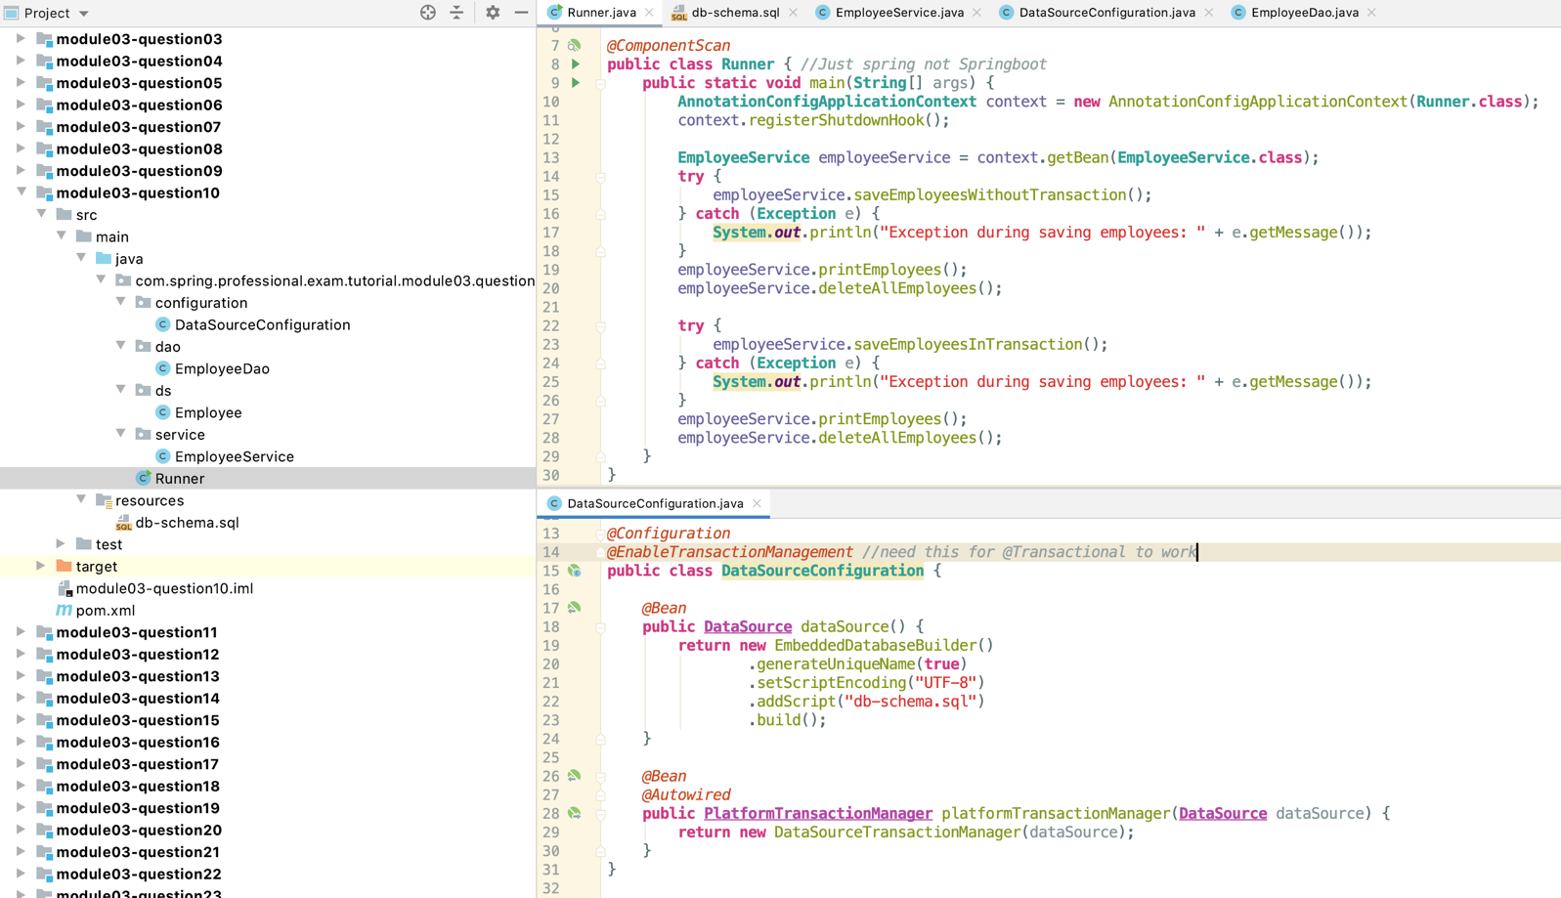

# Question 11 -Is the JDBC template able to participate in an existing transaction?

Yes, JDBC Template is able to participate in existing transaction. It will support both, transaction created with @Transactional annotation and also programmatically created transaction.

JDBC Template is able to participate in existing transaction by usage of DataSourceUtils and TransactionSynchronizationManager. TransactionInterceptor and TransactionAspectSupport are also using PlatformTransactionManager together with DataSourceTransactionManager which will set transaction in TransactionSynchronizationManager for JDBC Template (or other components) to reuse.

# Question 12 -What is a transaction isolation level? How many do we have and how are they ordered?

Transaction Isolation determines how changes made under one transaction are visible in other transactions and to other users of the system. Higher isolation level means that changes from one transaction are not visible and lower isolation level means that changes from one transactions may “slip” into selects executed under other transaction.

Higher transaction isolation level make data being visible in more consistent way, lower transaction isolation level makes data less consistent but increases overall throughput and concurrency of the system.

There are three challenges that may occur due to Transaction Isolation Level:

Phantom Read

Non-repeatable Read

Dirty read

## 12.1 Phantom read

* Transaction A -first read
  + select id, first_name, last_namefrom employees where id between 5 and 10
* Transaction B -write
  + insert into employees values(7, ‘John’, ‘Doe’);
* Transaction A -second read
  + select id, first_name, last_namefrom employees where id between 5 and 10

High Isolation Level will make second read returning same values as first read, lower isolation level will include new row with id 7 in second read.

To prevent phantom read, you need to pick isolation level that uses range locks.

## 12.2 Non-repeatable read

* Transaction A -first read
  + select id, first_name, last_namefrom employees where id = 5
* Transaction B –write & commit
  + update employees set last_name= ‘Doe’ where id = 5
* Transaction A -second read
  + select id, first_name, last_namefrom employees where id = 5

High Isolation Level will make second read returning same values as first read, lower isolation level will read new values for record 5.

To prevent non-repeatable reads you need to use isolation level that uses read-write locks on data being processed.

## 12.3 Dirty read

* Transaction A -first read
  + select id, first_name, last_namefrom employees where id = 5
* Transaction B –write (commit does not have to happen)
  + update employees set last_name= ‘Doe’ where id = 5
* Transaction A -second read
  + select id, first_name, last_namefrom employees where id = 5

High Isolation Level will make second read returning same values as first read, lower isolation level will read new values for record 5, even if Transaction B will not commit the data.

To prevent dirty reads you need to use isolation level that prevents uncommitted changes by other transaction being visible in your transaction.

## 12.4 Transaction Levels

Most Relational Databases support 4 transaction levels:

* Serializable
  + Highest Isolation Level
  + Read-Write Locks held until end of transaction
  + Range Locks held until end of transaction
* Repeatable Read
  + Read-Write Locks held until end of transaction
* Read Committed
  + Read Locks held until end of select statement
  + Write Locks held until end of transaction
* Read Uncommitted
  + Lowest isolation level
  + It is possible to see changes from other transactions that are not committed

In Spring Framework, you can use @Transactional annotation to set isolation level.

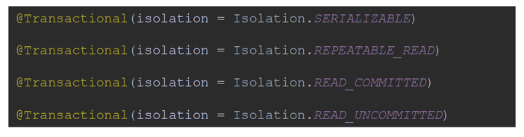

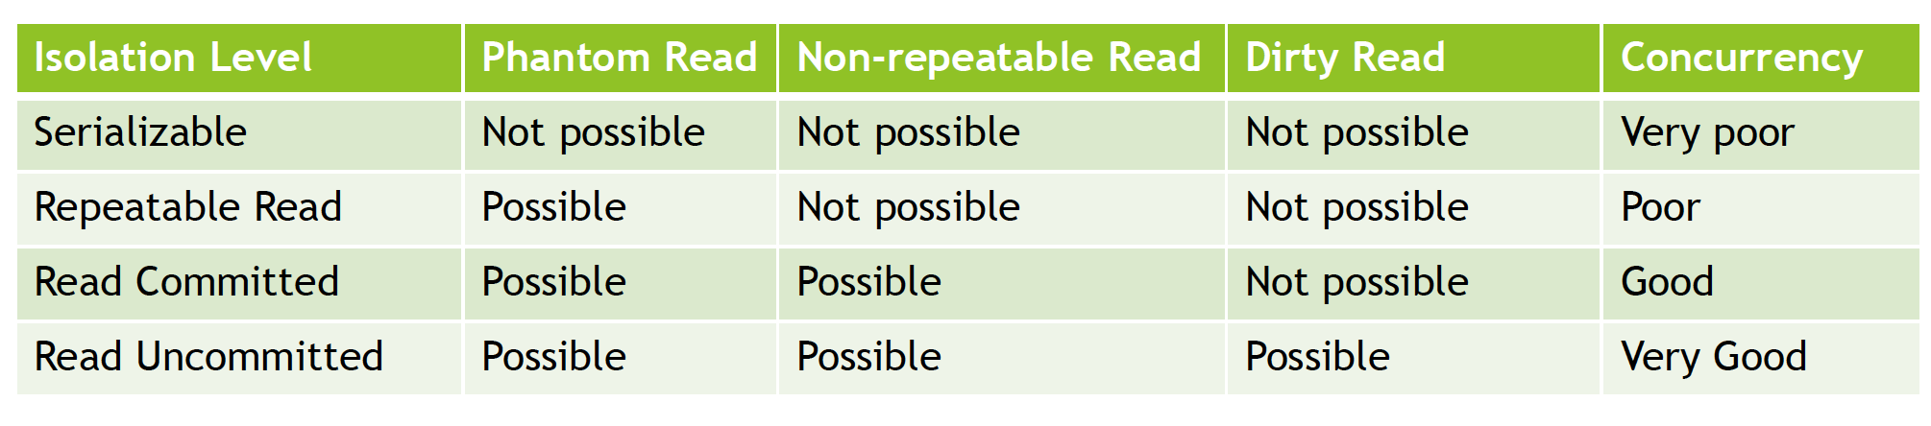

## @Serializable

Starting Repeatable Read Example

Starting Reading Thread

First Read Operation - second transaction did not save data yet

Starting Writing Thread

Employee(id=1, firstName=John, lastName=Doe, email=John.Doe@corp.com, phoneNumber=555-55-55, hireDate=2019-06-05, salary=70000.0)

Employee(id=2, firstName=Willow, lastName=Zhang, email=Willow.Zhang@corp.com, phoneNumber=555-55-56, hireDate=2019-07-12, salary=80000.0)

Employee(id=3, firstName=Jayvon, lastName=Grant, email=Jayvon.Grant@corp.com, phoneNumber=555-55-57, hireDate=2019-07-17, salary=90000.0)

Employee(id=5, firstName=Shaylee, lastName=Mcclure, email=Shaylee.Mcclure@corp.com, phoneNumber=555-55-58, hireDate=2019-07-19, salary=120000.0)

Employee(id=6, firstName=Miley, lastName=Krueger, email=Miley.Krueger@corp.com, phoneNumber=555-55-59, hireDate=2019-07-20, salary=110000.0)

Write Operation

Finishing Repeatable Read Example

Second Read Operation - second transaction did save data, but did not commit

Employee(id=1, firstName=John, lastName=Doe, email=John.Doe@corp.com, phoneNumber=555-55-55, hireDate=2019-06-05, salary=70000.0)

Employee(id=2, firstName=Willow, lastName=Zhang, email=Willow.Zhang@corp.com, phoneNumber=555-55-56, hireDate=2019-07-12, salary=80000.0)

Employee(id=3, firstName=Jayvon, lastName=Grant, email=Jayvon.Grant@corp.com, phoneNumber=555-55-57, hireDate=2019-07-17, salary=90000.0)

Employee(id=5, firstName=Shaylee, lastName=Mcclure, email=Shaylee.Mcclure@corp.com, phoneNumber=555-55-58, hireDate=2019-07-19, salary=120000.0)

Employee(id=6, firstName=Miley, lastName=Krueger, email=Miley.Krueger@corp.com, phoneNumber=555-55-59, hireDate=2019-07-20, salary=110000.0)

Third Read Operation - second transaction did save and commit data

Employee(id=1, firstName=John, lastName=Doe, email=John.Doe@corp.com, phoneNumber=555-55-55, hireDate=2019-06-05, salary=70000.0)

Employee(id=2, firstName=Willow, lastName=Zhang, email=Willow.Zhang@corp.com, phoneNumber=555-55-56, hireDate=2019-07-12, salary=80000.0)

Employee(id=3, firstName=Jayvon, lastName=Grant, email=Jayvon.Grant@corp.com, phoneNumber=555-55-57, hireDate=2019-07-17, salary=90000.0)

Employee(id=5, firstName=Shaylee, lastName=Mcclure, email=Shaylee.Mcclure@corp.com, phoneNumber=555-55-58, hireDate=2019-07-19, salary=120000.0)

Employee(id=6, firstName=Miley, lastName=Krueger, email=Miley.Krueger@corp.com, phoneNumber=555-55-59, hireDate=2019-07-20, salary=110000.0)

Finishing Reading Thread

Saved employee [4]

Updated employee email [6]

Finishing Writing Thread, Write Transaction will be committed

Fourth Read Operation - second transaction did save and commit data, new read transaction created

Employee(id=1, firstName=John, lastName=Doe, email=John.Doe@corp.com, phoneNumber=555-55-55, hireDate=2019-06-05, salary=70000.0)

Employee(id=2, firstName=Willow, lastName=Zhang, email=Willow.Zhang@corp.com, phoneNumber=555-55-56, hireDate=2019-07-12, salary=80000.0)

Employee(id=3, firstName=Jayvon, lastName=Grant, email=Jayvon.Grant@corp.com, phoneNumber=555-55-57, hireDate=2019-07-17, salary=90000.0)

Employee(id=5, firstName=Shaylee, lastName=Mcclure, email=Shaylee.Mcclure@corp.com, phoneNumber=555-55-58, hireDate=2019-07-19, salary=120000.0)

Employee(id=6, firstName=Miley, lastName=Krueger, email=XXX.XXX@XXX.XXX, phoneNumber=555-55-59, hireDate=2019-07-20, salary=110000.0)

Employee(id=4, firstName=Mary, lastName=Duncan, email=Mary.Duncam@cor.com, phoneNumber=555-55-60, hireDate=2019-07-30, salary=130000.0)

## @Repeatable_read

Starting Repeatable Read Example

Starting Writing Thread

Starting Reading Thread

First Read Operation - second transaction did not save data yet

Employee(id=1, firstName=John, lastName=Doe, email=John.Doe@corp.com, phoneNumber=555-55-55, hireDate=2019-06-05, salary=70000.0)

Employee(id=2, firstName=Willow, lastName=Zhang, email=Willow.Zhang@corp.com, phoneNumber=555-55-56, hireDate=2019-07-12, salary=80000.0)

Employee(id=3, firstName=Jayvon, lastName=Grant, email=Jayvon.Grant@corp.com, phoneNumber=555-55-57, hireDate=2019-07-17, salary=90000.0)

Employee(id=5, firstName=Shaylee, lastName=Mcclure, email=Shaylee.Mcclure@corp.com, phoneNumber=555-55-58, hireDate=2019-07-19, salary=120000.0)

Employee(id=6, firstName=Miley, lastName=Krueger, email=Miley.Krueger@corp.com, phoneNumber=555-55-59, hireDate=2019-07-20, salary=110000.0)

Write Operation

Saved employee [4]

Updated employee email [6]

Second Read Operation - second transaction did save data, but did not commit

Employee(id=1, firstName=John, lastName=Doe, email=John.Doe@corp.com, phoneNumber=555-55-55, hireDate=2019-06-05, salary=70000.0)

Employee(id=2, firstName=Willow, lastName=Zhang, email=Willow.Zhang@corp.com, phoneNumber=555-55-56, hireDate=2019-07-12, salary=80000.0)

Employee(id=3, firstName=Jayvon, lastName=Grant, email=Jayvon.Grant@corp.com, phoneNumber=555-55-57, hireDate=2019-07-17, salary=90000.0)

Employee(id=5, firstName=Shaylee, lastName=Mcclure, email=Shaylee.Mcclure@corp.com, phoneNumber=555-55-58, hireDate=2019-07-19, salary=120000.0)

Employee(id=6, firstName=Miley, lastName=Krueger, email=Miley.Krueger@corp.com, phoneNumber=555-55-59, hireDate=2019-07-20, salary=110000.0)

Finishing Writing Thread, Write Transaction will be committed

Third Read Operation - second transaction did save and commit data

Employee(id=1, firstName=John, lastName=Doe, email=John.Doe@corp.com, phoneNumber=555-55-55, hireDate=2019-06-05, salary=70000.0)

Employee(id=2, firstName=Willow, lastName=Zhang, email=Willow.Zhang@corp.com, phoneNumber=555-55-56, hireDate=2019-07-12, salary=80000.0)

Employee(id=3, firstName=Jayvon, lastName=Grant, email=Jayvon.Grant@corp.com, phoneNumber=555-55-57, hireDate=2019-07-17, salary=90000.0)

Employee(id=5, firstName=Shaylee, lastName=Mcclure, email=Shaylee.Mcclure@corp.com, phoneNumber=555-55-58, hireDate=2019-07-19, salary=120000.0)

Employee(id=6, firstName=Miley, lastName=Krueger, email=Miley.Krueger@corp.com, phoneNumber=555-55-59, hireDate=2019-07-20, salary=110000.0)

Finishing Reading Thread

Fourth Read Operation - second transaction did save and commit data, new read transaction created

Employee(id=1, firstName=John, lastName=Doe, email=John.Doe@corp.com, phoneNumber=555-55-55, hireDate=2019-06-05, salary=70000.0)

Employee(id=2, firstName=Willow, lastName=Zhang, email=Willow.Zhang@corp.com, phoneNumber=555-55-56, hireDate=2019-07-12, salary=80000.0)

Employee(id=3, firstName=Jayvon, lastName=Grant, email=Jayvon.Grant@corp.com, phoneNumber=555-55-57, hireDate=2019-07-17, salary=90000.0)

Employee(id=5, firstName=Shaylee, lastName=Mcclure, email=Shaylee.Mcclure@corp.com, phoneNumber=555-55-58, hireDate=2019-07-19, salary=120000.0)

Employee(id=6, firstName=Miley, lastName=Krueger, email=XXX.XXX@XXX.XXX, phoneNumber=555-55-59, hireDate=2019-07-20, salary=110000.0)

Employee(id=4, firstName=Mary, lastName=Duncan, email=Mary.Duncam@cor.com, phoneNumber=555-55-60, hireDate=2019-07-30, salary=130000.0)

Finishing Repeatable Read Example

## @Read_committed

Starting Repeatable Read Example

Starting Reading Thread

Starting Writing Thread

First Read Operation - second transaction did not save data yet

Employee(id=1, firstName=John, lastName=Doe, email=John.Doe@corp.com, phoneNumber=555-55-55, hireDate=2019-06-05, salary=70000.0)

Employee(id=2, firstName=Willow, lastName=Zhang, email=Willow.Zhang@corp.com, phoneNumber=555-55-56, hireDate=2019-07-12, salary=80000.0)

Employee(id=3, firstName=Jayvon, lastName=Grant, email=Jayvon.Grant@corp.com, phoneNumber=555-55-57, hireDate=2019-07-17, salary=90000.0)

Employee(id=5, firstName=Shaylee, lastName=Mcclure, email=Shaylee.Mcclure@corp.com, phoneNumber=555-55-58, hireDate=2019-07-19, salary=120000.0)

Employee(id=6, firstName=Miley, lastName=Krueger, email=Miley.Krueger@corp.com, phoneNumber=555-55-59, hireDate=2019-07-20, salary=110000.0)

Write Operation

Saved employee [4]

Updated employee email [6]

Second Read Operation - second transaction did save data, but did not commit

Employee(id=1, firstName=John, lastName=Doe, email=John.Doe@corp.com, phoneNumber=555-55-55, hireDate=2019-06-05, salary=70000.0)

Employee(id=2, firstName=Willow, lastName=Zhang, email=Willow.Zhang@corp.com, phoneNumber=555-55-56, hireDate=2019-07-12, salary=80000.0)

Employee(id=3, firstName=Jayvon, lastName=Grant, email=Jayvon.Grant@corp.com, phoneNumber=555-55-57, hireDate=2019-07-17, salary=90000.0)

Employee(id=5, firstName=Shaylee, lastName=Mcclure, email=Shaylee.Mcclure@corp.com, phoneNumber=555-55-58, hireDate=2019-07-19, salary=120000.0)

Employee(id=6, firstName=Miley, lastName=Krueger, email=Miley.Krueger@corp.com, phoneNumber=555-55-59, hireDate=2019-07-20, salary=110000.0)

Finishing Writing Thread, Write Transaction will be committed

Third Read Operation - second transaction did save and commit data

Employee(id=1, firstName=John, lastName=Doe, email=John.Doe@corp.com, phoneNumber=555-55-55, hireDate=2019-06-05, salary=70000.0)

Employee(id=2, firstName=Willow, lastName=Zhang, email=Willow.Zhang@corp.com, phoneNumber=555-55-56, hireDate=2019-07-12, salary=80000.0)

Employee(id=3, firstName=Jayvon, lastName=Grant, email=Jayvon.Grant@corp.com, phoneNumber=555-55-57, hireDate=2019-07-17, salary=90000.0)

Employee(id=5, firstName=Shaylee, lastName=Mcclure, email=Shaylee.Mcclure@corp.com, phoneNumber=555-55-58, hireDate=2019-07-19, salary=120000.0)

Employee(id=6, firstName=Miley, lastName=Krueger, email=XXX.XXX@XXX.XXX, phoneNumber=555-55-59, hireDate=2019-07-20, salary=110000.0)

Employee(id=4, firstName=Mary, lastName=Duncan, email=Mary.Duncam@cor.com, phoneNumber=555-55-60, hireDate=2019-07-30, salary=130000.0)

Finishing Reading Thread

Fourth Read Operation - second transaction did save and commit data, new read transaction created

Employee(id=1, firstName=John, lastName=Doe, email=John.Doe@corp.com, phoneNumber=555-55-55, hireDate=2019-06-05, salary=70000.0)

Employee(id=2, firstName=Willow, lastName=Zhang, email=Willow.Zhang@corp.com, phoneNumber=555-55-56, hireDate=2019-07-12, salary=80000.0)

Employee(id=3, firstName=Jayvon, lastName=Grant, email=Jayvon.Grant@corp.com, phoneNumber=555-55-57, hireDate=2019-07-17, salary=90000.0)

Employee(id=5, firstName=Shaylee, lastName=Mcclure, email=Shaylee.Mcclure@corp.com, phoneNumber=555-55-58, hireDate=2019-07-19, salary=120000.0)

Employee(id=6, firstName=Miley, lastName=Krueger, email=XXX.XXX@XXX.XXX, phoneNumber=555-55-59, hireDate=2019-07-20, salary=110000.0)

Employee(id=4, firstName=Mary, lastName=Duncan, email=Mary.Duncam@cor.com, phoneNumber=555-55-60, hireDate=2019-07-30, salary=130000.0)

Finishing Repeatable Read Example

## @Read_uncommitted

Starting Repeatable Read Example

Starting Reading Thread

First Read Operation - second transaction did not save data yet

Starting Writing Thread

Employee(id=1, firstName=John, lastName=Doe, email=John.Doe@corp.com, phoneNumber=555-55-55, hireDate=2019-06-05, salary=70000.0)

Employee(id=2, firstName=Willow, lastName=Zhang, email=Willow.Zhang@corp.com, phoneNumber=555-55-56, hireDate=2019-07-12, salary=80000.0)

Employee(id=3, firstName=Jayvon, lastName=Grant, email=Jayvon.Grant@corp.com, phoneNumber=555-55-57, hireDate=2019-07-17, salary=90000.0)

Employee(id=5, firstName=Shaylee, lastName=Mcclure, email=Shaylee.Mcclure@corp.com, phoneNumber=555-55-58, hireDate=2019-07-19, salary=120000.0)

Employee(id=6, firstName=Miley, lastName=Krueger, email=Miley.Krueger@corp.com, phoneNumber=555-55-59, hireDate=2019-07-20, salary=110000.0)

Write Operation

Saved employee [4]

Updated employee email [6]

Second Read Operation - second transaction did save data, but did not commit

Employee(id=1, firstName=John, lastName=Doe, email=John.Doe@corp.com, phoneNumber=555-55-55, hireDate=2019-06-05, salary=70000.0)

Employee(id=2, firstName=Willow, lastName=Zhang, email=Willow.Zhang@corp.com, phoneNumber=555-55-56, hireDate=2019-07-12, salary=80000.0)

Employee(id=3, firstName=Jayvon, lastName=Grant, email=Jayvon.Grant@corp.com, phoneNumber=555-55-57, hireDate=2019-07-17, salary=90000.0)

Employee(id=5, firstName=Shaylee, lastName=Mcclure, email=Shaylee.Mcclure@corp.com, phoneNumber=555-55-58, hireDate=2019-07-19, salary=120000.0)

Employee(id=6, firstName=Miley, lastName=Krueger, email=XXX.XXX@XXX.XXX, phoneNumber=555-55-59, hireDate=2019-07-20, salary=110000.0)

Employee(id=4, firstName=Mary, lastName=Duncan, email=Mary.Duncam@cor.com, phoneNumber=555-55-60, hireDate=2019-07-30, salary=130000.0)

Finishing Writing Thread, Write Transaction will be committed

Third Read Operation - second transaction did save and commit data

Employee(id=1, firstName=John, lastName=Doe, email=John.Doe@corp.com, phoneNumber=555-55-55, hireDate=2019-06-05, salary=70000.0)

Employee(id=2, firstName=Willow, lastName=Zhang, email=Willow.Zhang@corp.com, phoneNumber=555-55-56, hireDate=2019-07-12, salary=80000.0)

Employee(id=3, firstName=Jayvon, lastName=Grant, email=Jayvon.Grant@corp.com, phoneNumber=555-55-57, hireDate=2019-07-17, salary=90000.0)

Employee(id=5, firstName=Shaylee, lastName=Mcclure, email=Shaylee.Mcclure@corp.com, phoneNumber=555-55-58, hireDate=2019-07-19, salary=120000.0)

Employee(id=6, firstName=Miley, lastName=Krueger, email=XXX.XXX@XXX.XXX, phoneNumber=555-55-59, hireDate=2019-07-20, salary=110000.0)

Employee(id=4, firstName=Mary, lastName=Duncan, email=Mary.Duncam@cor.com, phoneNumber=555-55-60, hireDate=2019-07-30, salary=130000.0)

Finishing Reading Thread

Fourth Read Operation - second transaction did save and commit data, new read transaction created

Employee(id=1, firstName=John, lastName=Doe, email=John.Doe@corp.com, phoneNumber=555-55-55, hireDate=2019-06-05, salary=70000.0)

Employee(id=2, firstName=Willow, lastName=Zhang, email=Willow.Zhang@corp.com, phoneNumber=555-55-56, hireDate=2019-07-12, salary=80000.0)

Employee(id=3, firstName=Jayvon, lastName=Grant, email=Jayvon.Grant@corp.com, phoneNumber=555-55-57, hireDate=2019-07-17, salary=90000.0)

Employee(id=5, firstName=Shaylee, lastName=Mcclure, email=Shaylee.Mcclure@corp.com, phoneNumber=555-55-58, hireDate=2019-07-19, salary=120000.0)

Employee(id=6, firstName=Miley, lastName=Krueger, email=XXX.XXX@XXX.XXX, phoneNumber=555-55-59, hireDate=2019-07-20, salary=110000.0)

Employee(id=4, firstName=Mary, lastName=Duncan, email=Mary.Duncam@cor.com, phoneNumber=555-55-60, hireDate=2019-07-30, salary=130000.0)

Finishing Repeatable Read Example

*@Service  
//@Transactional(isolation = Isolation.SERIALIZABLE)  
//@Transactional(isolation = Isolation.REPEATABLE_READ)  
//@Transactional(isolation = Isolation.READ_COMMITTED)  
@Transactional*(isolation = **Isolation**.***READ_UNCOMMITTED***)  
**public class TransactionIsolationExample extends AbstractIsolationExample** {  
 **public void** readOperations() {  
 **System**.***out***.println("Starting Reading Thread");  
  
 **System**.***out***.println("First Read Operation - second transaction did not save data yet");  
 readOperation();  
 *countDown*(fistReadOnUnsavedAndNotCommittedLatch);  
  
 *await*(writeDoneNotCommittedLatch);  
 **System**.***out***.println("Second Read Operation - second transaction did save data, but did not commit");  
 readOperation();  
 *countDown*(secondReadOnSavedButNotCommittedLatch);  
  
 *await*(writeDoneAndCommittedLatch);  
 **System**.***out***.println("Third Read Operation - second transaction did save and commit data");  
 readOperation();  
  
 **System**.***out***.println("Finishing Reading Thread");  
 }  
  
 **public void** nextReadOperation() {  
 **System**.***out***.println("Fourth Read Operation - second transaction did save and commit data, new read transaction created");  
 readOperation();  
 }  
  
 **public void** writeOperations() {  
 **System**.***out***.println("Starting Writing Thread");  
  
 *await*(fistReadOnUnsavedAndNotCommittedLatch);  
 **System**.***out***.println("Write Operation");  
 writeOperation();  
 *countDown*(writeDoneNotCommittedLatch);  
  
 *await*(secondReadOnSavedButNotCommittedLatch);  
  
 **System**.***out***.println("Finishing Writing Thread, Write Transaction will be committed");  
 }  
}

*@Component***public class TransactionIsolationExampleInvoker** {  
 *@Autowired* **private TransactionIsolationExample** transactionIsolationExample;  
  
 **private ExecutorService** executorService = **Executors**.*newFixedThreadPool*(2);  
  
 **public void** execute() {  
 **System**.***out***.println("Starting Repeatable Read Example");  
  
 executorService.execute(() -> {  
 transactionIsolationExample.readOperations();  
 transactionIsolationExample.nextReadOperation();  
  
 *countDown*(transactionIsolationExample.getReadWriteLatch());  
 });  
  
 executorService.execute(() -> {  
 transactionIsolationExample.writeOperations();  
 *countDown*(transactionIsolationExample.getWriteDoneAndCommittedLatch());  
  
 *countDown*(transactionIsolationExample.getReadWriteLatch());  
 });  
  
 *await*(transactionIsolationExample.getReadWriteLatch());  
  
 executorService.shutdown();  
  
 **System**.***out***.println("Finishing Repeatable Read Example");  
 }  
}

*@Getter***abstract class AbstractIsolationExample** {  
 *@Autowired* **private EmployeeDao** employeeDao;  
  
 **CountDownLatch** fistReadOnUnsavedAndNotCommittedLatch = **new** CountDownLatch(1);  
 **CountDownLatch** secondReadOnSavedButNotCommittedLatch = **new** CountDownLatch(1);  
 **CountDownLatch** writeDoneNotCommittedLatch = **new** CountDownLatch(1);  
 **CountDownLatch** writeDoneAndCommittedLatch = **new** CountDownLatch(1);  
 **CountDownLatch** readWriteLatch = **new** CountDownLatch(2);  
  
 **void** readOperation() {  
 employeeDao.findAllEmployeesByIdRange(1, 6).forEach(**System**.***out***::println);  
 }  
  
 **void** writeOperation() {  
 employeeDao.saveEmployee(**new** Employee(4, "Mary", "Duncan", "Mary.Duncam@cor.com", "555-55-60", **Date**.*valueOf*("2019-07-30"), 130000));  
 employeeDao.maskEmail(6);  
 }  
}

*@Repository***public class EmployeeDao** {  
 **private JdbcTemplate** jdbcTemplate;  
  
 *@Autowired* **public void** setDataSource(**DataSource** dataSource) {  
 jdbcTemplate = **new** JdbcTemplate(dataSource);  
 }  
  
 **public List**<**Employee**> findAllEmployeesByIdRange(**int** minId, **int** maxId) {  
 **return** jdbcTemplate.query(  
 "select employee_id, first_name, last_name, email, phone_number, hire_date, salary " +  
 "from employee " +  
 "where employee_id between ? and ?",  
 **new** Object[]{minId, maxId},  
 **this**::mapEmployee  
 );  
 }  
  
 **public void** saveEmployee(**Employee** employee) {  
 **int** numberOfRecordsInserted = jdbcTemplate.update(  
 "insert into employee(employee_id, first_name, last_name, email, phone_number, hire_date, salary) " +  
 "values (?, ?, ?, ?, ?, ?, ?)",  
 employee.getId(),  
 employee.getFirstName(),  
 employee.getLastName(),  
 employee.getEmail(),  
 employee.getPhoneNumber(),  
 employee.getHireDate(),  
 employee.getSalary()  
 );  
  
 **if** (numberOfRecordsInserted == 1)  
 **System**.***out***.println(**String**.*format*("Saved employee [%d]", employee.getId()));  
 **else  
 throw new** IllegalStateException(**String**.*format*("Expected 1 record to be inserted, instead retrieved [%d] number of records inserted", numberOfRecordsInserted));  
 }  
  
 **public void** maskEmail(**int** id) {  
 **int** numberOfUpdatesRows = jdbcTemplate.update(  
 "update employee set email='XXX.XXX@XXX.XXX' where employee_id = ?",  
 id  
 );  
  
 **if** (numberOfUpdatesRows == 1)  
 **System**.***out***.println(**String**.*format*("Updated employee email [%d]", id));  
 **else  
 throw new** IllegalStateException(**String**.*format*("Expected 1 record to be updated, instead updated [%d] number of records inserted", numberOfUpdatesRows));  
 }  
  
 *@SneakyThrows* **private Employee** mapEmployee(**ResultSet** resultSet, **int** i) {  
 **return new** Employee(  
 resultSet.getInt("employee_id"),  
 resultSet.getString("first_name"),  
 resultSet.getString("last_name"),  
 resultSet.getString("email"),  
 resultSet.getString("phone_number"),  
 resultSet.getDate("hire_date"),  
 resultSet.getFloat("salary")  
 );  
 }  
}

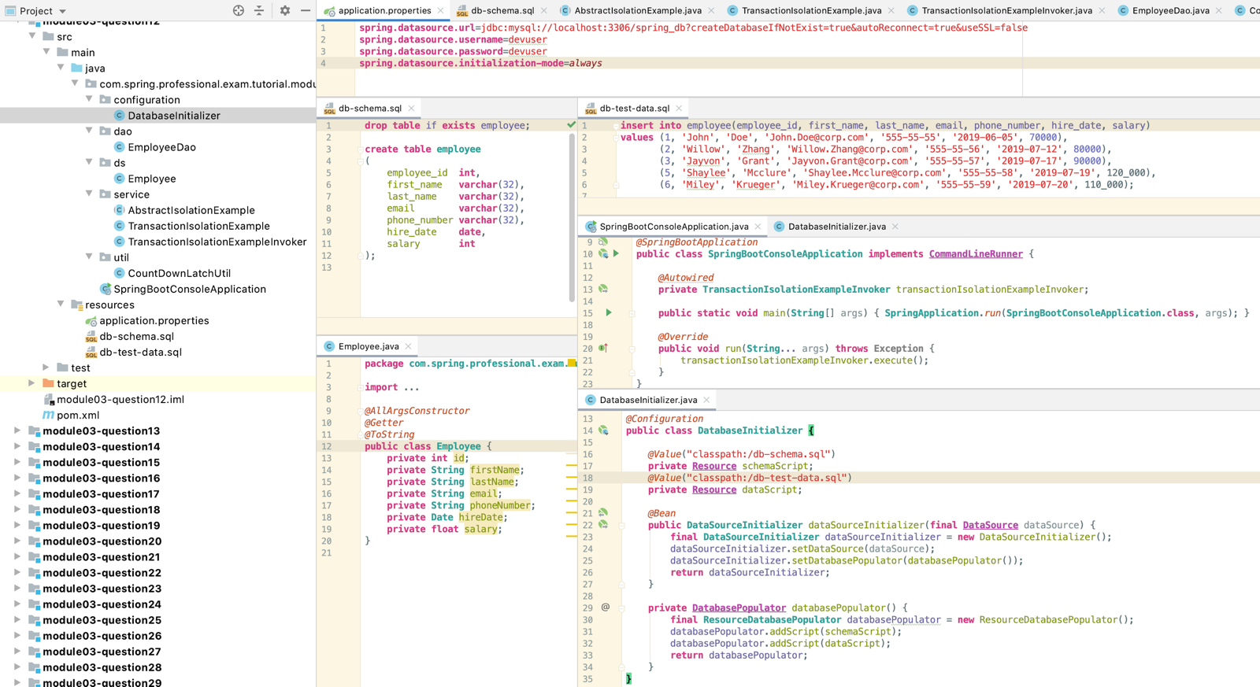

# Question 13 -What is @EnableTransactionManagementfor?

@EnableTransactionManagementannotation is used on top of @Configurationclass to enable annotation-driven transaction management by @Transactional annotation in Spring Framework.

When @EnableTransactionManagementis used, TransactionInterceptor and TransactionAspectSupport will be used to proxy each call to @Transactional class or method, which will use PlatformTransactionManager to manage transaction.

@EnableTransactionManagement allows you to specify following values:

* Mode –sets advice mode for @Transactional annotation, indicates how calls to methods should be intercepted, PROXY is default mode, you can switch it to more advanced ASPECTJ weaving advice, which supports local calls
* Order –indicates order of advice execution when more then one advice applies to @Transactional join point
* proxyTargetClass–indicates whether CGLIBProxyclasses should be created or if JDK Proxies should be created (default), this field is used only when Modeis set to PROXY

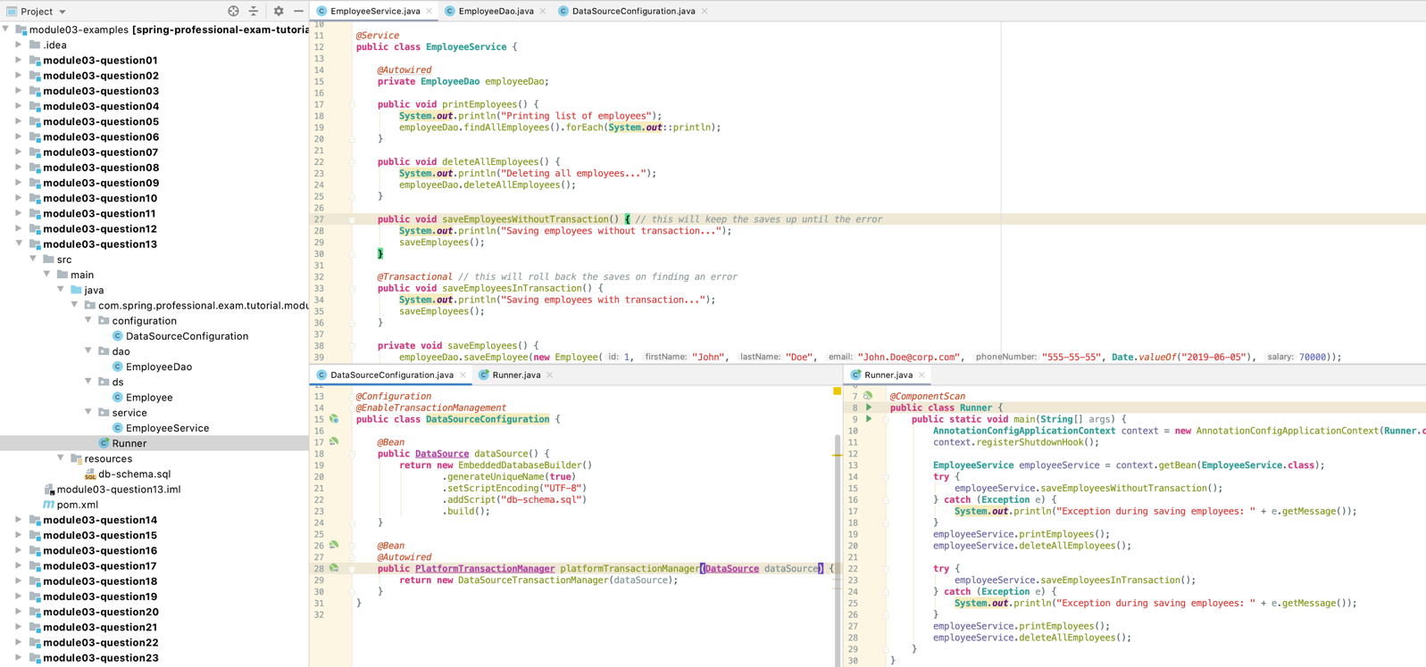

Saving employees without transaction...

Saved employee [1]

Saved employee [2]

Saved employee [3]

Exception during saving employees: Employee Id has to be greater than zero

Printing list of employees

Employee(id=1, firstName=John, lastName=Doe, email=John.Doe@corp.com, phoneNumber=555-55-55, hireDate=2019-06-05, salary=70000.0)

Employee(id=2, firstName=Willow, lastName=Zhang, email=Willow.Zhang@corp.com, phoneNumber=555-55-56, hireDate=2019-07-12, salary=80000.0)

Employee(id=3, firstName=Jayvon, lastName=Grant, email=Jayvon.Grant@corp.com, phoneNumber=555-55-57, hireDate=2019-07-17, salary=90000.0)

Deleting all employees...

Employees deleted, number of deleted rows = [3]

Saving employees with transaction...

Saved employee [1]

Saved employee [2]

Saved employee [3]

Exception during saving employees: Employee Id has to be greater than zero

Printing list of employees

Deleting all employees...

Employees deleted, number of deleted rows = [0]

# Question 14 -What does transaction propagation mean?

Transaction propagation defines how existing transaction is re-used when calling @Transactional method with transaction already running.

Transaction propagation can be defined in @Transactional annotation in propagation field as one of following options:

* REQUIRED-support a current transaction, create a new one if none exists
* SUPPORTS-support a current transaction, execute non-transactionally if none exists
* MANDATORY-support a current transaction, throw an exception if none exists
* REQUIRES_NEW-create a new transaction, and suspend the current transaction if one exists
* NOT_SUPPORTED-execute non-transactionally, suspend the current transaction if one exists
* NEVER-execute non-transactionally, throw an exception if a transaction exists
* NESTED-execute within a nested transaction if a current transaction exists, behave like REQUIRED else

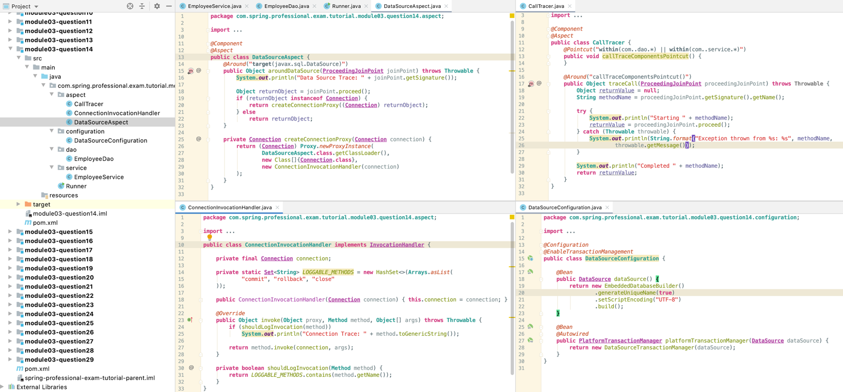

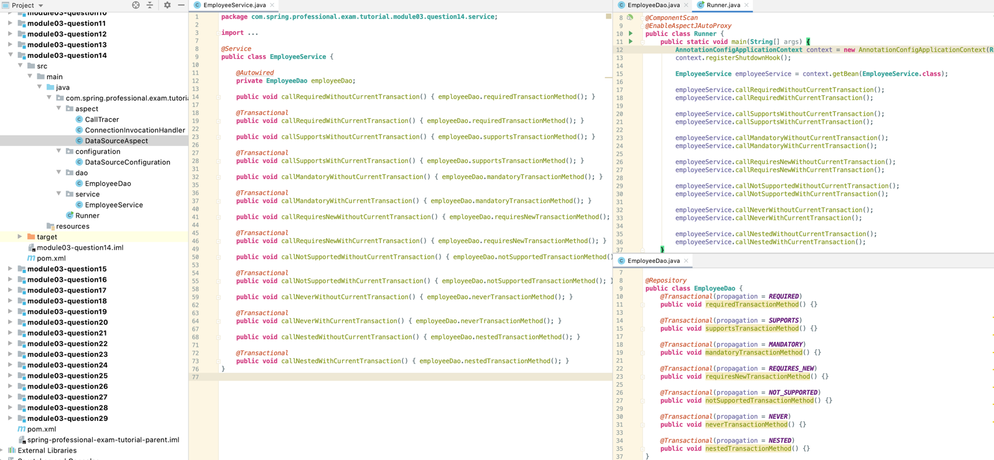

Starting callRequiredWithoutCurrentTransaction

Data Source Trace: Connection javax.sql.DataSource.getConnection()

Starting requiredTransactionMethod

Completed requiredTransactionMethod

Connection Trace: public abstract void java.sql.Connection.commit() throws java.sql.SQLException

Connection Trace: public abstract void java.sql.Connection.close() throws java.sql.SQLException

Completed callRequiredWithoutCurrentTransaction

Data Source Trace: Connection javax.sql.DataSource.getConnection()

Starting callRequiredWithCurrentTransaction

Starting requiredTransactionMethod

Completed requiredTransactionMethod

Completed callRequiredWithCurrentTransaction

Connection Trace: public abstract void java.sql.Connection.commit() throws java.sql.SQLException

Connection Trace: public abstract void java.sql.Connection.close() throws java.sql.SQLException

Starting callSupportsWithoutCurrentTransaction

Starting supportsTransactionMethod

Completed supportsTransactionMethod

Completed callSupportsWithoutCurrentTransaction

Data Source Trace: Connection javax.sql.DataSource.getConnection()

Starting callSupportsWithCurrentTransaction

Starting supportsTransactionMethod

Completed supportsTransactionMethod

Completed callSupportsWithCurrentTransaction

Connection Trace: public abstract void java.sql.Connection.commit() throws java.sql.SQLException

Connection Trace: public abstract void java.sql.Connection.close() throws java.sql.SQLException

Starting callMandatoryWithoutCurrentTransaction

Exception thrown from callMandatoryWithoutCurrentTransaction: No existing transaction found for transaction marked with propagation 'mandatory'

Completed callMandatoryWithoutCurrentTransaction

Data Source Trace: Connection javax.sql.DataSource.getConnection()

Starting callMandatoryWithCurrentTransaction

Starting mandatoryTransactionMethod

Completed mandatoryTransactionMethod

Completed callMandatoryWithCurrentTransaction

Connection Trace: public abstract void java.sql.Connection.commit() throws java.sql.SQLException

Connection Trace: public abstract void java.sql.Connection.close() throws java.sql.SQLException

Starting callRequiresNewWithoutCurrentTransaction

Data Source Trace: Connection javax.sql.DataSource.getConnection()

Starting requiresNewTransactionMethod

Completed requiresNewTransactionMethod

Connection Trace: public abstract void java.sql.Connection.commit() throws java.sql.SQLException

Connection Trace: public abstract void java.sql.Connection.close() throws java.sql.SQLException

Completed callRequiresNewWithoutCurrentTransaction

Data Source Trace: Connection javax.sql.DataSource.getConnection()

Starting callRequiresNewWithCurrentTransaction

Data Source Trace: Connection javax.sql.DataSource.getConnection()

Starting requiresNewTransactionMethod

Completed requiresNewTransactionMethod

Connection Trace: public abstract void java.sql.Connection.commit() throws java.sql.SQLException

Connection Trace: public abstract void java.sql.Connection.close() throws java.sql.SQLException

Completed callRequiresNewWithCurrentTransaction

Connection Trace: public abstract void java.sql.Connection.commit() throws java.sql.SQLException

Connection Trace: public abstract void java.sql.Connection.close() throws java.sql.SQLException

Starting callNotSupportedWithoutCurrentTransaction

Starting notSupportedTransactionMethod

Completed notSupportedTransactionMethod

Completed callNotSupportedWithoutCurrentTransaction

Data Source Trace: Connection javax.sql.DataSource.getConnection()

Starting callNotSupportedWithCurrentTransaction

Starting notSupportedTransactionMethod

Completed notSupportedTransactionMethod

Completed callNotSupportedWithCurrentTransaction

Connection Trace: public abstract void java.sql.Connection.commit() throws java.sql.SQLException

Connection Trace: public abstract void java.sql.Connection.close() throws java.sql.SQLException

Starting callNeverWithoutCurrentTransaction

Starting neverTransactionMethod

Completed neverTransactionMethod

Completed callNeverWithoutCurrentTransaction

Data Source Trace: Connection javax.sql.DataSource.getConnection()

Starting callNeverWithCurrentTransaction

Exception thrown from callNeverWithCurrentTransaction: Existing transaction found for transaction marked with propagation 'never'

Completed callNeverWithCurrentTransaction

Connection Trace: public abstract void java.sql.Connection.commit() throws java.sql.SQLException

Connection Trace: public abstract void java.sql.Connection.close() throws java.sql.SQLException

Starting callNestedWithoutCurrentTransaction

Data Source Trace: Connection javax.sql.DataSource.getConnection()

Starting nestedTransactionMethod

Completed nestedTransactionMethod

Connection Trace: public abstract void java.sql.Connection.commit() throws java.sql.SQLException

Connection Trace: public abstract void java.sql.Connection.close() throws java.sql.SQLException

Completed callNestedWithoutCurrentTransaction

Data Source Trace: Connection javax.sql.DataSource.getConnection()

Starting callNestedWithCurrentTransaction

Starting nestedTransactionMethod

Completed nestedTransactionMethod

Completed callNestedWithCurrentTransaction

Connection Trace: public abstract void java.sql.Connection.commit() throws java.sql.SQLException

Connection Trace: public abstract void java.sql.Connection.close() throws java.sql.SQLException

# Question 15 -What happens if one @Transactional annotated method is calling another @Transactional annotated method on the same object instance?

JDK Proxy and CGLIB Proxy in Spring Beans AOP do not support self invocation, so when one method with @Transactional annotation calls different method with @Transactional annotation from the same class, nothing happens, transaction interceptor will not be called.

To enable self invocation support, you need to configure Spring Aspects with AspectJ, to do that you need to:

* Have dependency to spring-aspects
* Includeaspectj-maven-plugin
* ConfigureTransactionSupportwith@EnableTransactionManagement(mode = AdviceMode.ASPECTJ)

## 15.1 Spring Proxy

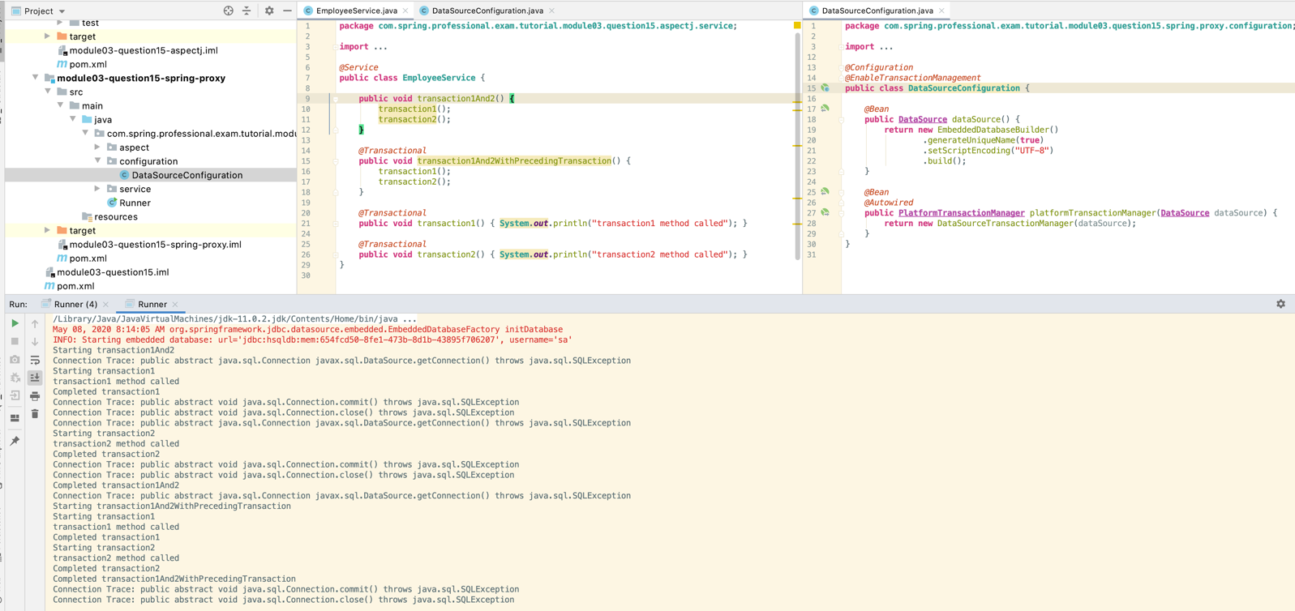

## 15.1 Aspect J

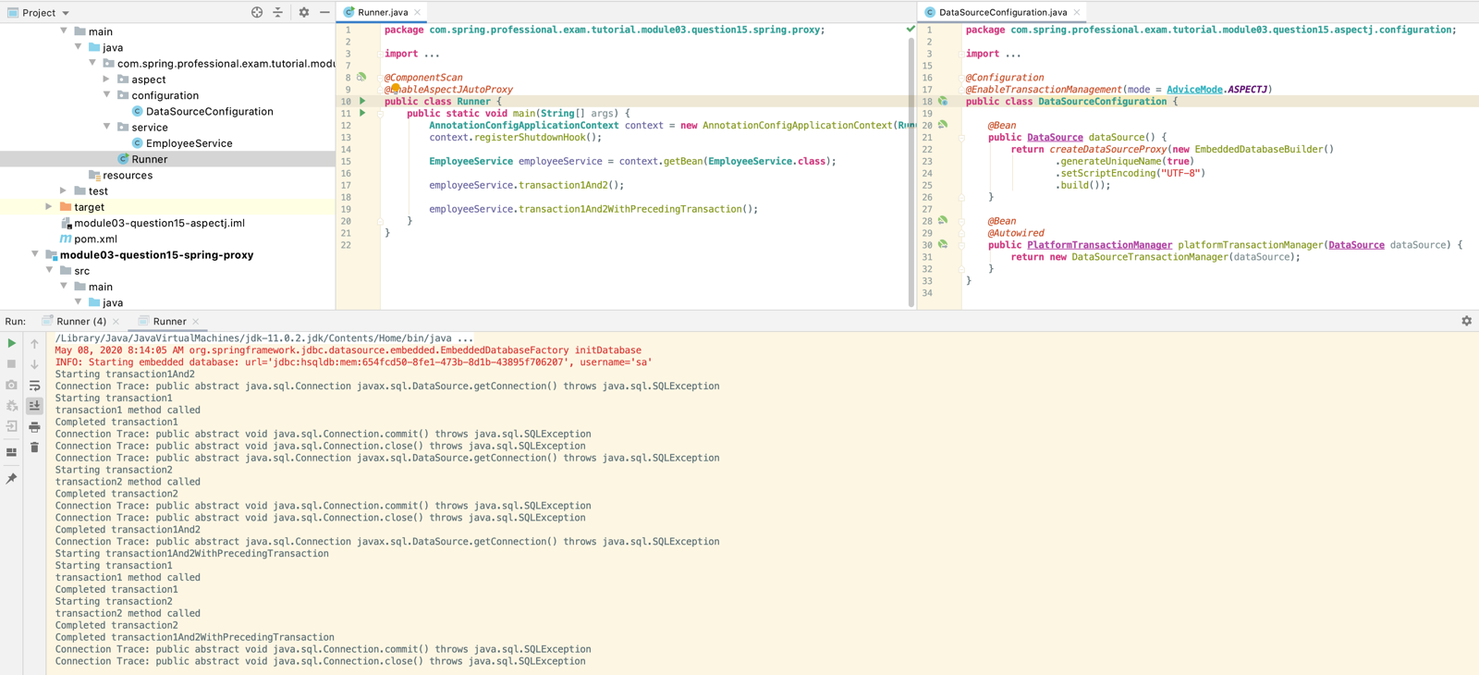

# Question 16 -Where can the @Transactional annotation be used? What is a typical usage if you put it at class level?

@Transactional can be used on top of **class** or **method**, in **classes** or **interfaces**.

If used on top of class, it applies to all public methods in this class.

If used on top of method, it needs to have public access modifier, if used on top of protected / package-visible / private method, transaction management will not be applied.

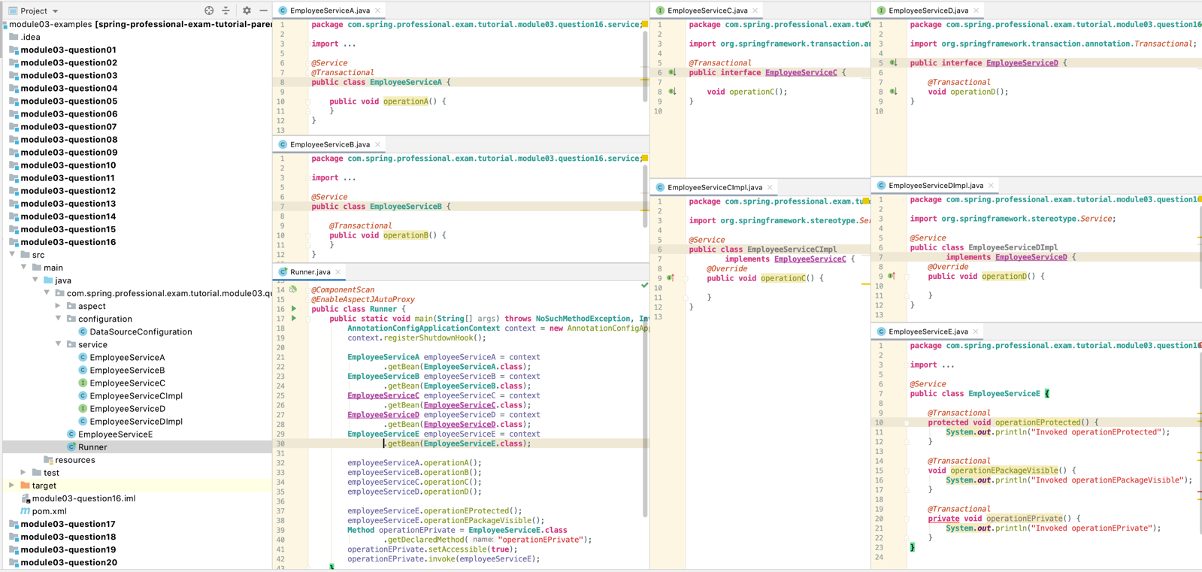

Data Source Trace: Connection javax.sql.DataSource.getConnection()

Starting operationA

Completed operationA

Connection Trace: public abstract void java.sql.Connection.commit() throws java.sql.SQLException

Connection Trace: public abstract void java.sql.Connection.close() throws java.sql.SQLException

Data Source Trace: Connection javax.sql.DataSource.getConnection()

Starting operationB

Completed operationB

Connection Trace: public abstract void java.sql.Connection.commit() throws java.sql.SQLException

Connection Trace: public abstract void java.sql.Connection.close() throws java.sql.SQLException

Data Source Trace: Connection javax.sql.DataSource.getConnection()

Starting operationC

Completed operationC

Connection Trace: public abstract void java.sql.Connection.commit() throws java.sql.SQLException

Connection Trace: public abstract void java.sql.Connection.close() throws java.sql.SQLException

Data Source Trace: Connection javax.sql.DataSource.getConnection()

Starting operationD

Completed operationD

Connection Trace: public abstract void java.sql.Connection.commit() throws java.sql.SQLException

Connection Trace: public abstract void java.sql.Connection.close() throws java.sql.SQLException

Invoked operationEProtected

Invoked operationEPackageVisible

Invoked operationEPrivate

# Question 17 -What does declarative transaction management mean?

Declarative transaction management means that instead of handling transactions manually through the code, methods which should be executed in transactions are declared with @Transactional annotation.

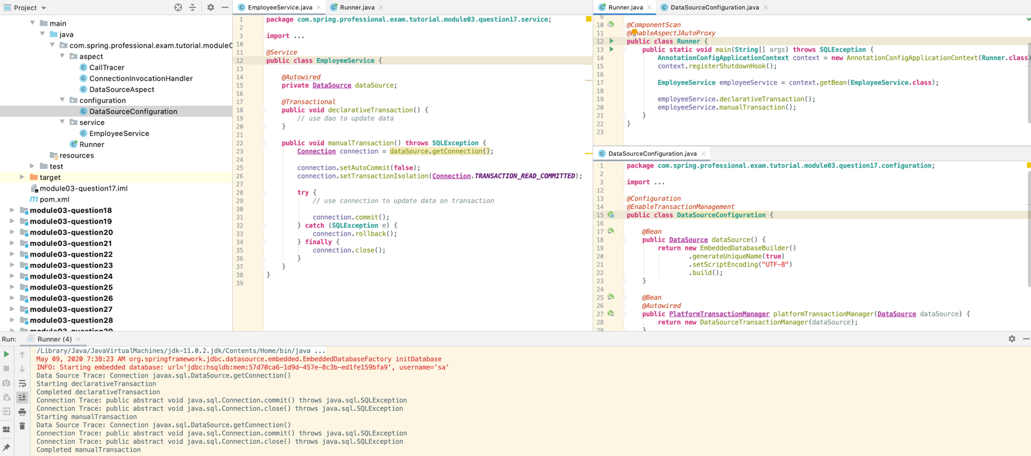

# Question 18 -What is the default rollback policy? How can you override it?

Default rollback policy in Spring Framework is set to automatic rollback, but only when unchecked exception is being thrown from the method annotated with @Transactional annotation. When checked exception is being thrown from the method, transaction is not being rolled back.

You can override this policy by setting rollbackFor/ rollbackForClassName or noRollbackFor / noRollbackForClassName field in @Transactional annotation.

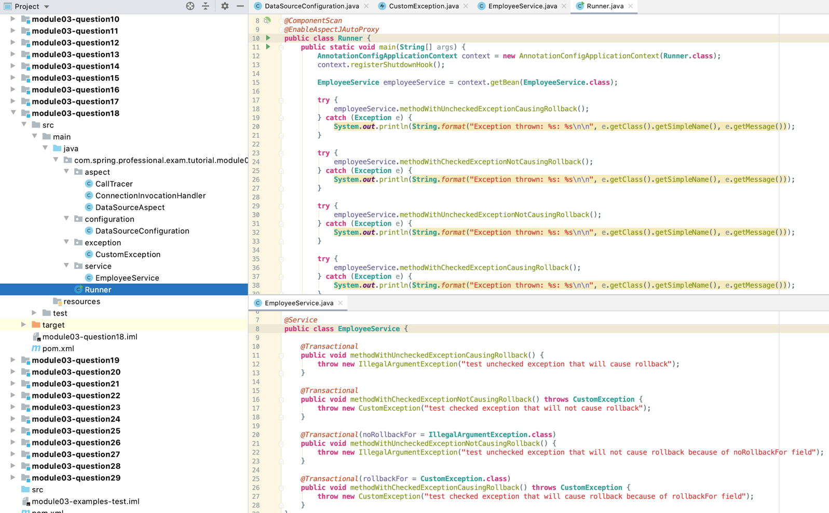

Data Source Trace: Connection javax.sql.DataSource.getConnection()

Starting methodWithUncheckedExceptionCausingRollback

Connection Trace: public abstract void java.sql.Connection.rollback() throws java.sql.SQLException

Connection Trace: public abstract void java.sql.Connection.close() throws java.sql.SQLException

Exception thrown: IllegalArgumentException: test unchecked exception that will cause rollback

Data Source Trace: Connection javax.sql.DataSource.getConnection()

Starting methodWithCheckedExceptionNotCausingRollback

Connection Trace: public abstract void java.sql.Connection.commit() throws java.sql.SQLException

Connection Trace: public abstract void java.sql.Connection.close() throws java.sql.SQLException

Exception thrown: CustomException: test checked exception that will not cause rollback

Data Source Trace: Connection javax.sql.DataSource.getConnection()

Starting methodWithUncheckedExceptionNotCausingRollback

Connection Trace: public abstract void java.sql.Connection.commit() throws java.sql.SQLException

Connection Trace: public abstract void java.sql.Connection.close() throws java.sql.SQLException

Exception thrown: IllegalArgumentException: test unchecked exception that will not cause rollback because of noRollbackFor field

Data Source Trace: Connection javax.sql.DataSource.getConnection()

Starting methodWithCheckedExceptionCausingRollback

Connection Trace: public abstract void java.sql.Connection.rollback() throws java.sql.SQLException

Connection Trace: public abstract void java.sql.Connection.close() throws java.sql.SQLException

Exception thrown: CustomException: test checked exception that will cause rollback because of rollbackFor field

# Question 19 -What is the default rollback policy in a JUnit test, when you use the @RunWith(SpringJUnit4ClassRunner.class) in JUnit 4 or @ExtendWith(SpringExtension.class) in JUnit 5, and annotate your @Test annotated method with @Transactional?

Default rollback policy in @Test methods annotated with @Transactional is always rollback. This means that after test execution transaction will always be rolled back. The reason for this is that each test method should be able to change state of database or call other classes that will change state of the database, however for the tests to be repeatable, changes should be reverted after @Test method execution.

You can change this behaviour by using @Rollback annotation set to false.

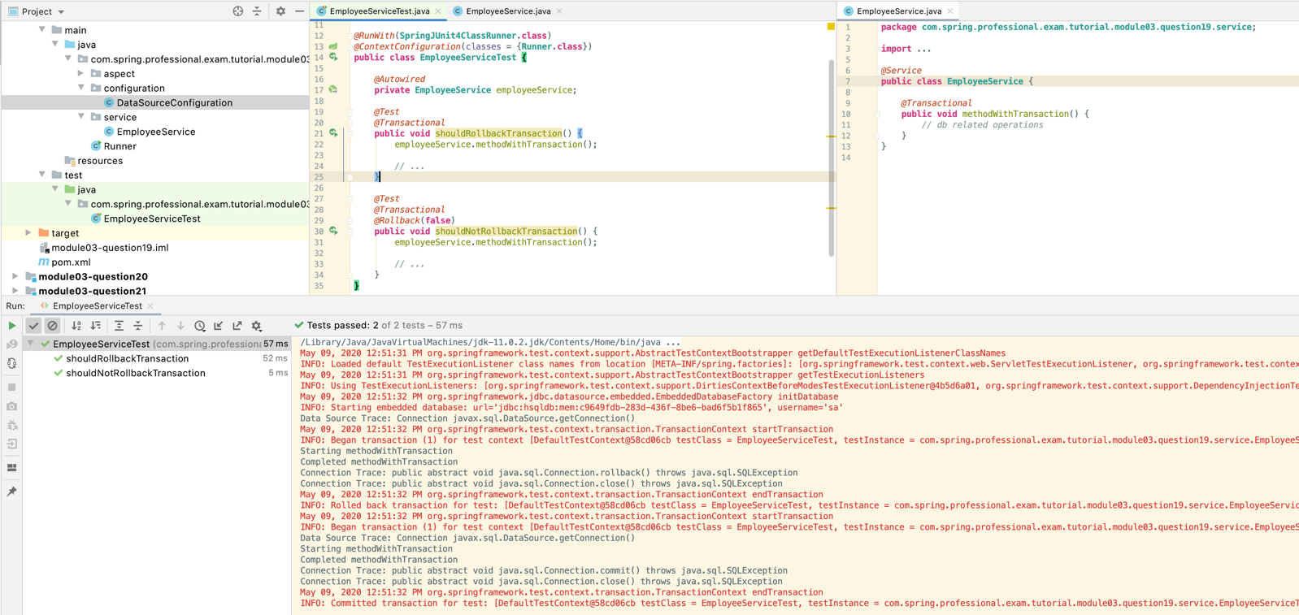

# Question 20-Why is the term "unit of work" so important and why does JDBC AutoCommit violate this pattern?

Unit of work is a generic term to describe, set of tasks that are performing some changes on the data, with assumption that all changes needs to be performed, or no changes should be performed at all.

In Relational Databases, Unit of Work can be represented by Database Transaction, which Atomic nature describes “all-or-nothing” behaviour described above.

In context of JPA/Hibernate, Unit of Work tracks all changes made to the Data Objects representing entries in the database, and once done, ORM figures out all changes that needs to be applied to the database. This way amount of calls to the database can be minimized by aggregating all changes into one call.

JDBC AutoCommit violates Unit of Work, because it makes every SQL statement being invoked in a separate transaction that is committed after SQL is executed, this makes impossible to implement Unit of Work consisting of multiple SQL operations.

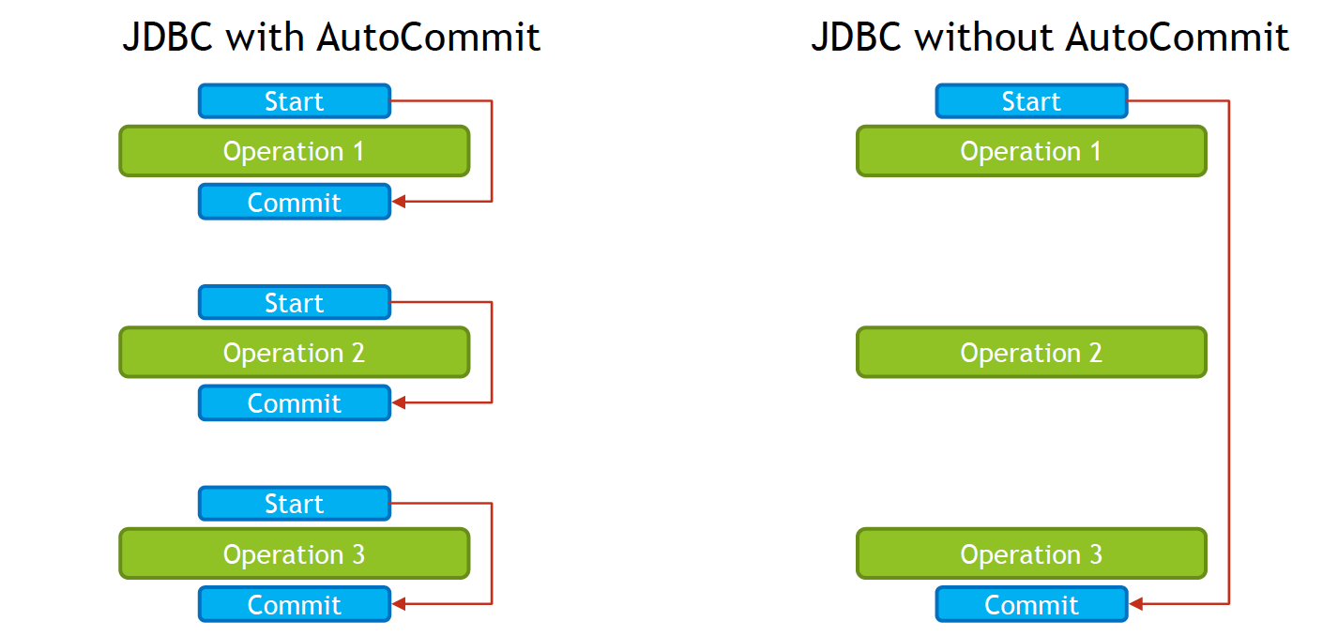

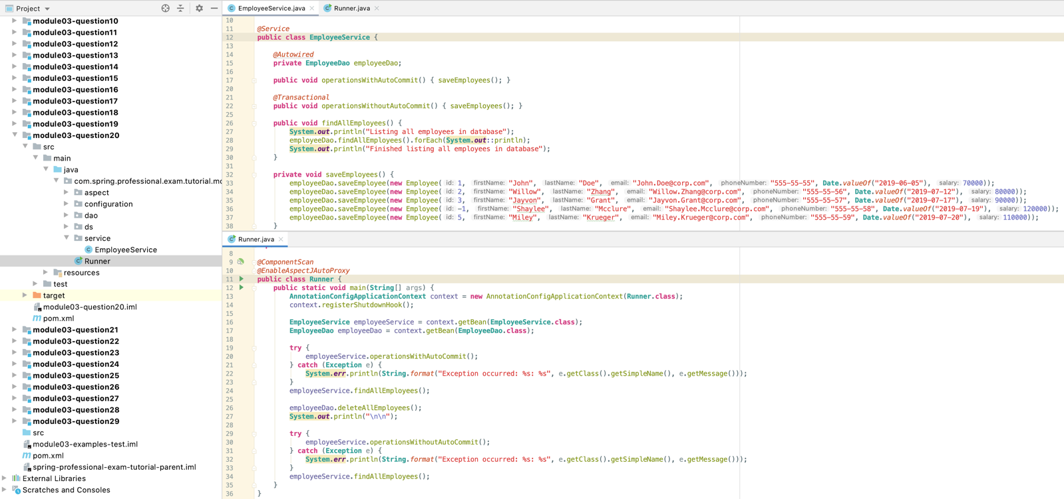

May 11, 2020 7:01:56 AM org.springframework.jdbc.datasource.embedded.EmbeddedDatabaseFactory initDatabase

INFO: Starting embedded database: url='jdbc:hsqldb:mem:0e29a4e3-0dc0-4f34-9499-928e5cb81cc3', username='sa'

Starting operationsWithAutoCommit

Saving employee [1]

Data Source Trace: Connection javax.sql.DataSource.getConnection()

Connection Trace: public abstract void java.sql.Connection.close() throws java.sql.SQLException

Saved employee [1]

Saving employee [2]

Data Source Trace: Connection javax.sql.DataSource.getConnection()

Connection Trace: public abstract void java.sql.Connection.close() throws java.sql.SQLException

Saved employee [2]

Saving employee [3]

Data Source Trace: Connection javax.sql.DataSource.getConnection()

Connection Trace: public abstract void java.sql.Connection.close() throws java.sql.SQLException

Saved employee [3]

Starting findAllEmployees

Listing all employees in database

Data Source Trace: Connection javax.sql.DataSource.getConnection()

Connection Trace: public abstract void java.sql.Connection.close() throws java.sql.SQLException

Exception occurred: IllegalArgumentException: Employee Id has to be greater than zero

Employee(id=1, firstName=John, lastName=Doe, email=John.Doe@corp.com, phoneNumber=555-55-55, hireDate=2019-06-05, salary=70000.0)

Employee(id=2, firstName=Willow, lastName=Zhang, email=Willow.Zhang@corp.com, phoneNumber=555-55-56, hireDate=2019-07-12, salary=80000.0)

Employee(id=3, firstName=Jayvon, lastName=Grant, email=Jayvon.Grant@corp.com, phoneNumber=555-55-57, hireDate=2019-07-17, salary=90000.0)

Finished listing all employees in database

Completed findAllEmployees

Data Source Trace: Connection javax.sql.DataSource.getConnection()

Connection Trace: public abstract void java.sql.Connection.close() throws java.sql.SQLException

Employees deleted, number of deleted rows = [3]

Data Source Trace: Connection javax.sql.DataSource.getConnection()

Connection Trace: public abstract void java.sql.Connection.setAutoCommit(boolean) throws java.sql.SQLException

Starting operationsWithoutAutoCommit

Saving employee [1]

Saved employee [1]

Saving employee [2]

Saved employee [2]

Saving employee [3]

Saved employee [3]

Connection Trace: public abstract void java.sql.Connection.rollback() throws java.sql.SQLException

Connection Trace: public abstract void java.sql.Connection.setAutoCommit(boolean) throws java.sql.SQLException

Connection Trace: public abstract void java.sql.Connection.close() throws java.sql.SQLException

Starting findAllEmployees

Listing all employees in database

Data Source Trace: Connection javax.sql.DataSource.getConnection()

Connection Trace: public abstract void java.sql.Connection.close() throws java.sql.SQLException

Finished listing all employees in database

Completed findAllEmployees

Exception occurred: IllegalArgumentException: Employee Id has to be greater than zero

# Question 21 -What do you need to do in Spring if you would like to work with JPA?

Following steps are required to work with JPA in Spring Framework:

* Declare maven dependencies:
  + JPA API -javax.persistence:javax.persistence-api
  + Spring ORM-org.springframework:spring-orm
  + ORM of your choice, for example -org.hibernate:hibernate-core
  + DatabaseDriver,forexample-org.hsqldb: hsqldb
  + Optionally,but recommended, Spring Data JPA -org.springframework.data:spring-data-jpa
* Define DataSourceBean
* DefinePlatformTransactionManager, in case of JPA JpaTransactionManager
* Define EntityManagerFactoryBean
  + LocalContainerEntityManagerFactoryBeanfor standalone application
  + EntityManagerFactoryfrom JNDI
  + LocalEntityManagerFactoryBeanfor Test purposes
* Define @Entity classes with at least on @Id field
* Define DAO classes, or use Spring Data JPA Repositories

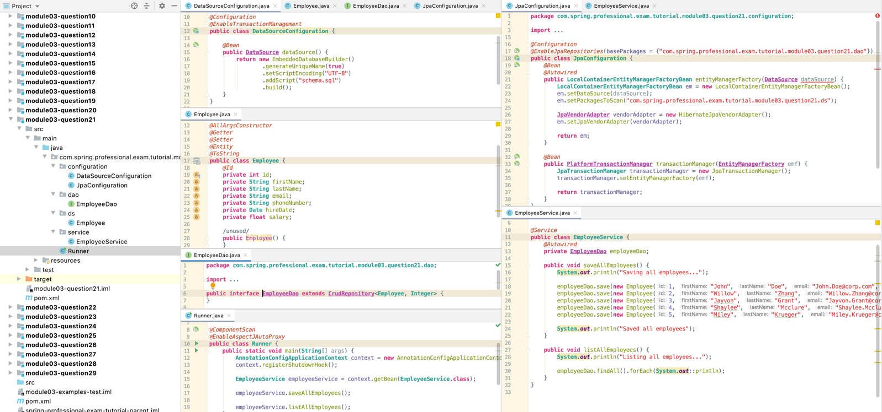

schema.sql

**create table employee**(  
 id **int**,  
 firstname **varchar**(32),  
 lastname **varchar**(32),  
 email **varchar**(32),  
 phonenumber **varchar**(32),  
 hiredate **date**,  
 salary **int**);

# Question 22-Are you able to participate in a given transaction in Spring while working with JPA?

Yes, JPA in Spring uses JpaTransactionManager, which supports cases when DataSource is used directly, so it allows mixing JPA and JDBC code under one transaction.

When using Spring Framework on Java EE platform, it is possible to reuse existing transactions as well by using JtaTransactionManager, which will delegate transaction management to Java EE container.

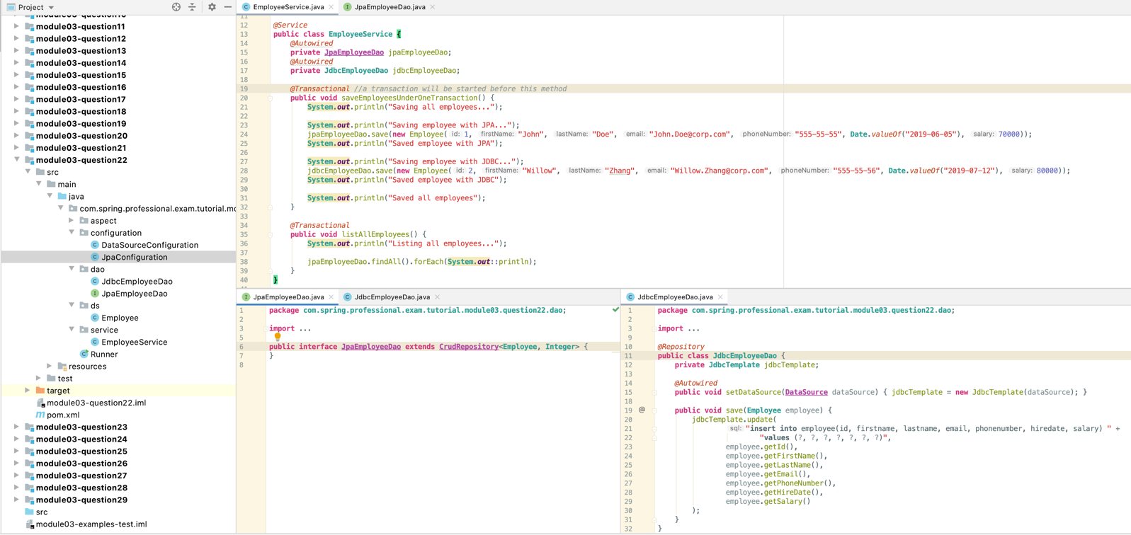

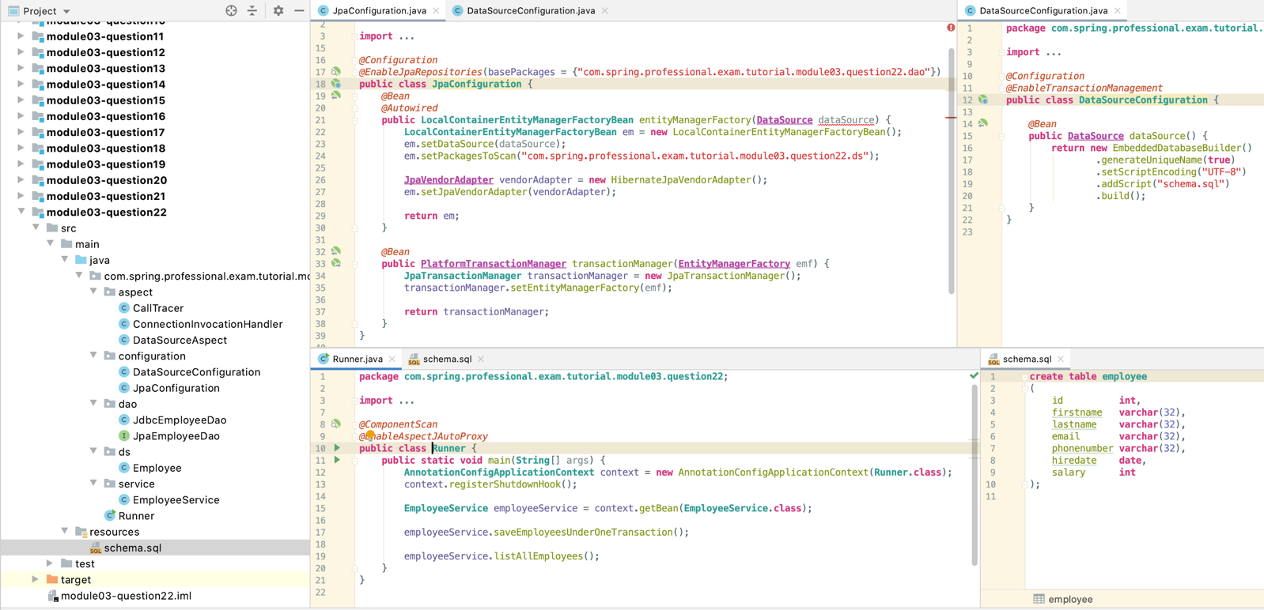

Data Source Trace: Connection javax.sql.DataSource.getConnection()

Connection Trace: public abstract void java.sql.Connection.setAutoCommit(boolean) throws java.sql.SQLException

Starting saveEmployeesUnderOneTransaction

Saving all employees...

Saving employee with JPA...

Saved employee with JPA

Saving employee with JDBC...

Saved employee with JDBC

Saved all employees

Completed saveEmployeesUnderOneTransaction

Connection Trace: public abstract void java.sql.Connection.commit() throws java.sql.SQLException

Connection Trace: public abstract void java.sql.Connection.setAutoCommit(boolean) throws java.sql.SQLException

Connection Trace: public abstract void java.sql.Connection.close() throws java.sql.SQLException

Data Source Trace: Connection javax.sql.DataSource.getConnection()

Connection Trace: public abstract void java.sql.Connection.setAutoCommit(boolean) throws java.sql.SQLException

Starting listAllEmployees

Listing all employees...

Employee(id=2, firstName=Willow, lastName=Zhang, email=Willow.Zhang@corp.com, phoneNumber=555-55-56, hireDate=2019-07-12, salary=80000.0)

Employee(id=1, firstName=John, lastName=Doe, email=John.Doe@corp.com, phoneNumber=555-55-55, hireDate=2019-06-05, salary=70000.0)

Completed listAllEmployees

Connection Trace: public abstract void java.sql.Connection.commit() throws java.sql.SQLException

Connection Trace: public abstract void java.sql.Connection.setAutoCommit(boolean) throws java.sql.SQLException

Connection Trace: public abstract void java.sql.Connection.close() throws java.sql.SQLException

# Question 23 -Which PlatformTransactionManager(s) can you use with JPA?

JPA can work with following transaction managers:

* JpaTransactionManager–recommended when working with one database and one Entity Manager
* JtaTransactionManager–recommended when working with multiple databases and Entity Managers, or when working with multiple databases and other transactional resources, for example one transaction needs to span Database and JMS Topic

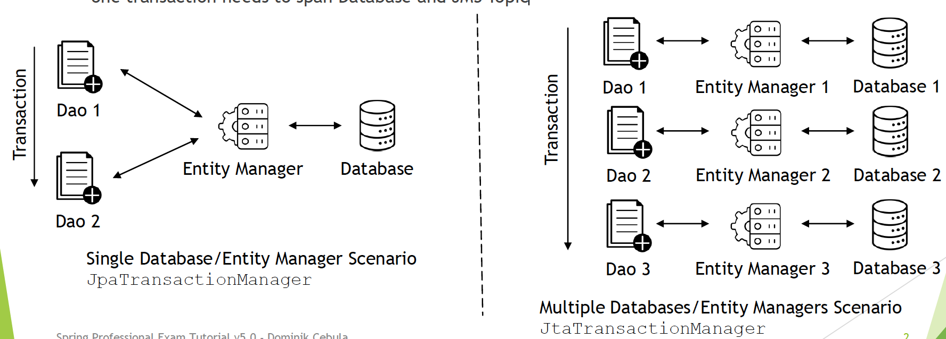

Usage of JpaTransactionManagerin case of multiple Databases / Transactional Resources / Entity Managers will cause each transaction, span only one resource, this is why JtaTransactionManager is required in this case.

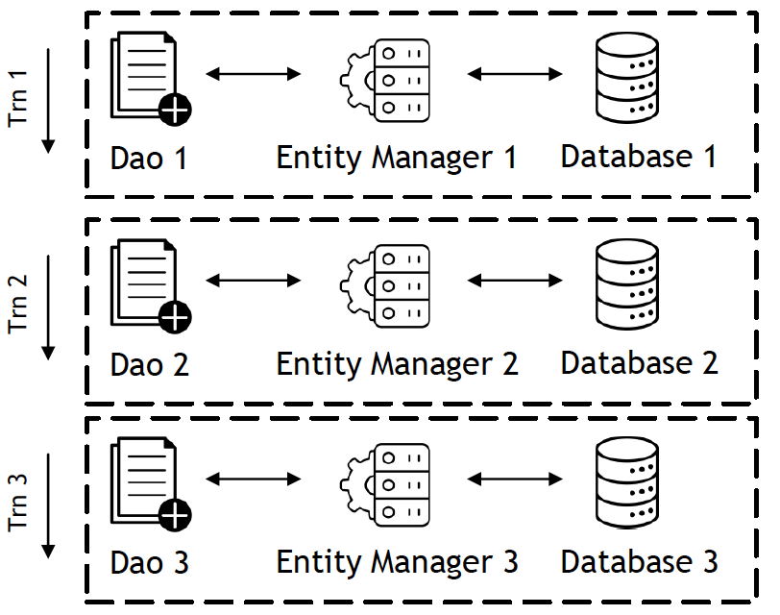

Multiple Databases/Entity Managers Scenario with incorrectly used **JpaTransactionManager**

for this case use **JtaTransactionManager**

## 23.1 JPA

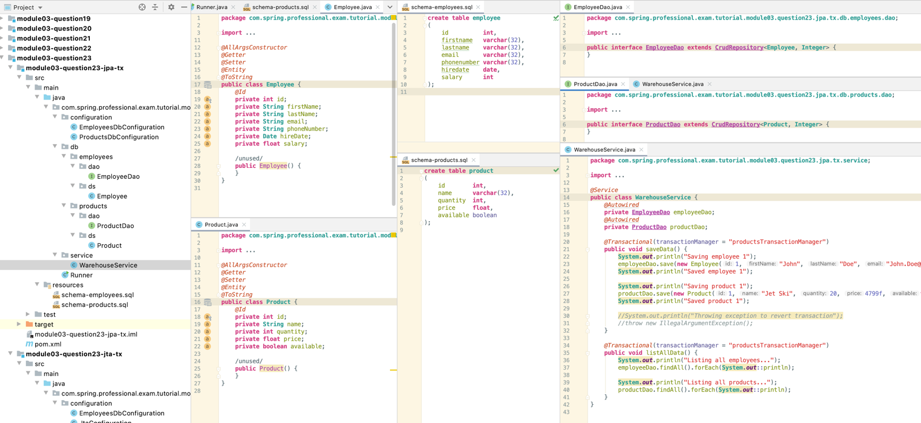

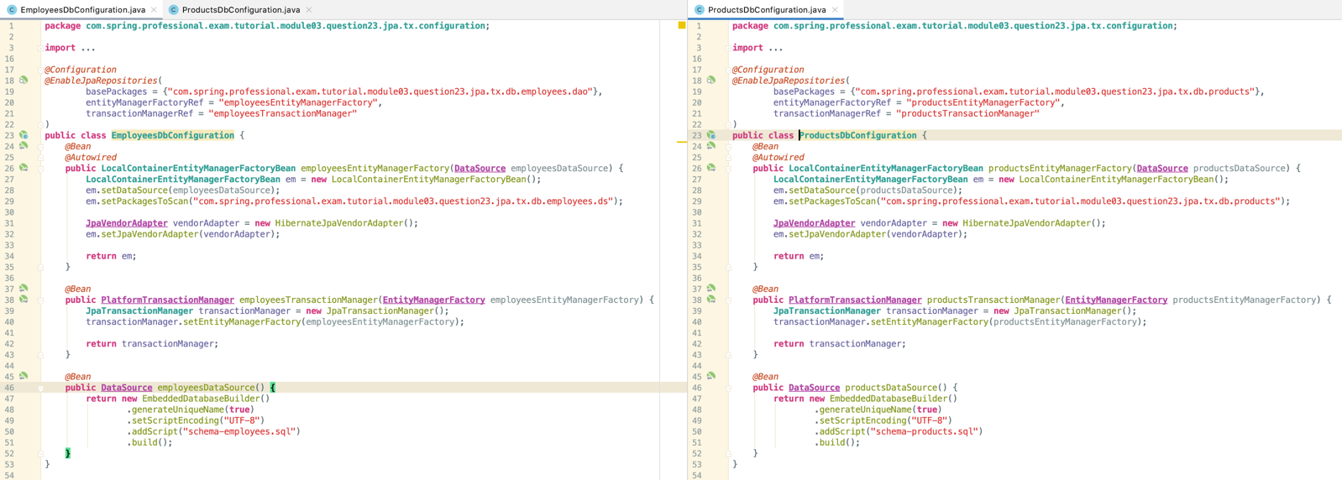

## 23.2 JTA

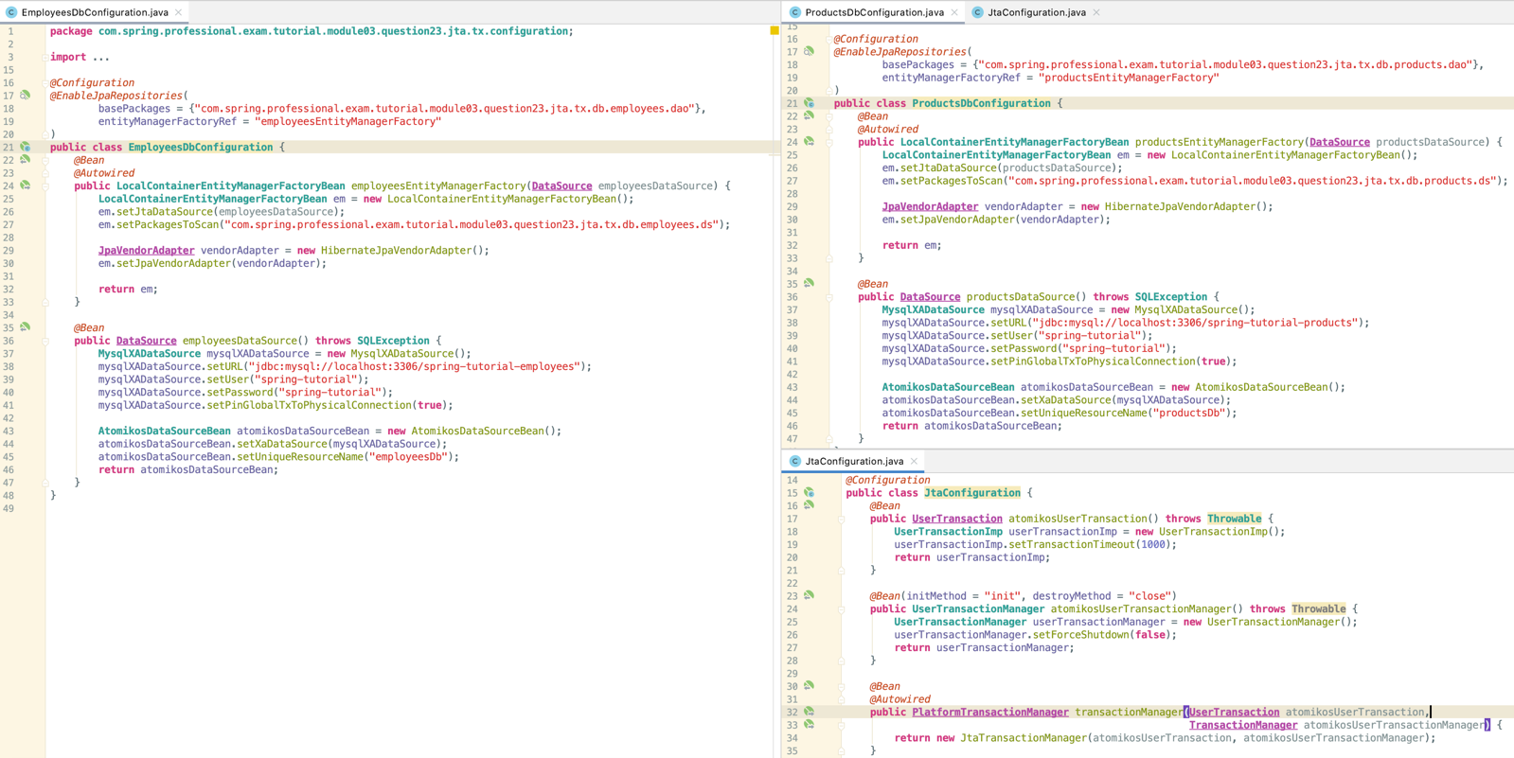

# Question 24 -What do you have to configure to use JPA with Spring? How does Spring Boot make this easier?

Following steps are required to work with JPA in Spring Framework:

* Declare maven dependencies:
  + JPA API -javax.persistence:javax.persistence-api
  + Spring ORM -org.springframework:spring-orm
  + ORM of your choice, for example -org.hibernate:hibernate-core
  + Database Driver, for example -org.hsqldb:hsqldb
  + Optionally, but recommended, Spring Data JPA -org.springframework.data:spring-data-jpa
* Define DataSourceBean
* Define PlatformTransactionManager, in case of JPA JpaTransactionManager
* Define EntityManagerFactoryBean
  + LocalContainerEntityManagerFactoryBeanfor standalone application
  + EntityManagerFactory from JNDI
  + LocalEntityManagerFactoryBean for Test purposes
* Define @Entity classes with at least on @Id field
* Define DAO classes, or use Spring Data JPA Repositories

Spring Boot simplifies JPA setup by:

* Providing spring-boot-starter-data-jpa dependency which includes all required dependencies
* Providing auto-configuration for JPA
* Automatically defines PlatformTransactionManager, EntityManagerand other required beans
* Allows Data Source to be configured via properties
* Provides out-of-the-box support for Hikari Connection Pool
* Provides default properties to JPA
* Automatically creates DAO beans for Repositories

## 24.1 Spring

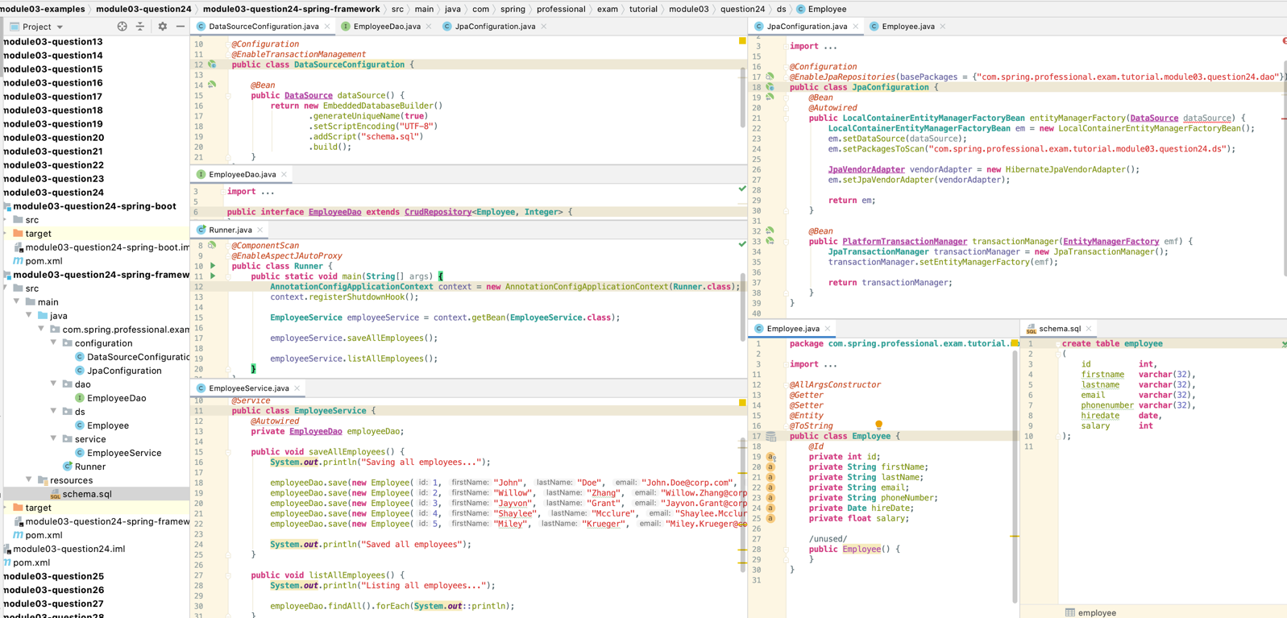

## 24.2 Springboot

## 

# Question 25 -What is a Repository interface?

Repository interface is a Java interface that describes Dao with expected behaviours, based on which Spring Data will automatically generate Dao logic. Repository interface takes Domain Class and ID of type to manage.

Custom Repository interface needs to extend one of following interface:

* Repository –basic marker repository
* CrudRepository–adds generic methods for CRUD operations
* PagingAndSortingRepository–adds findAll methods for paging/sorting
* JpaRepository–JPA specific extension of Repository

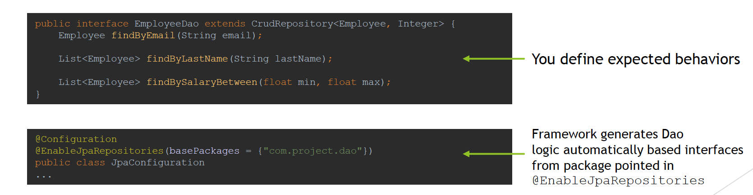

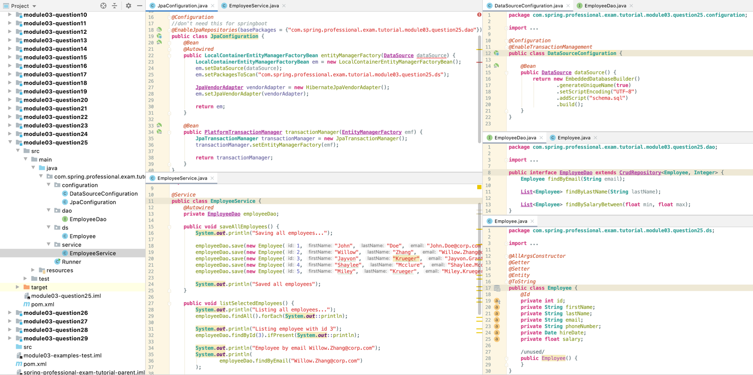

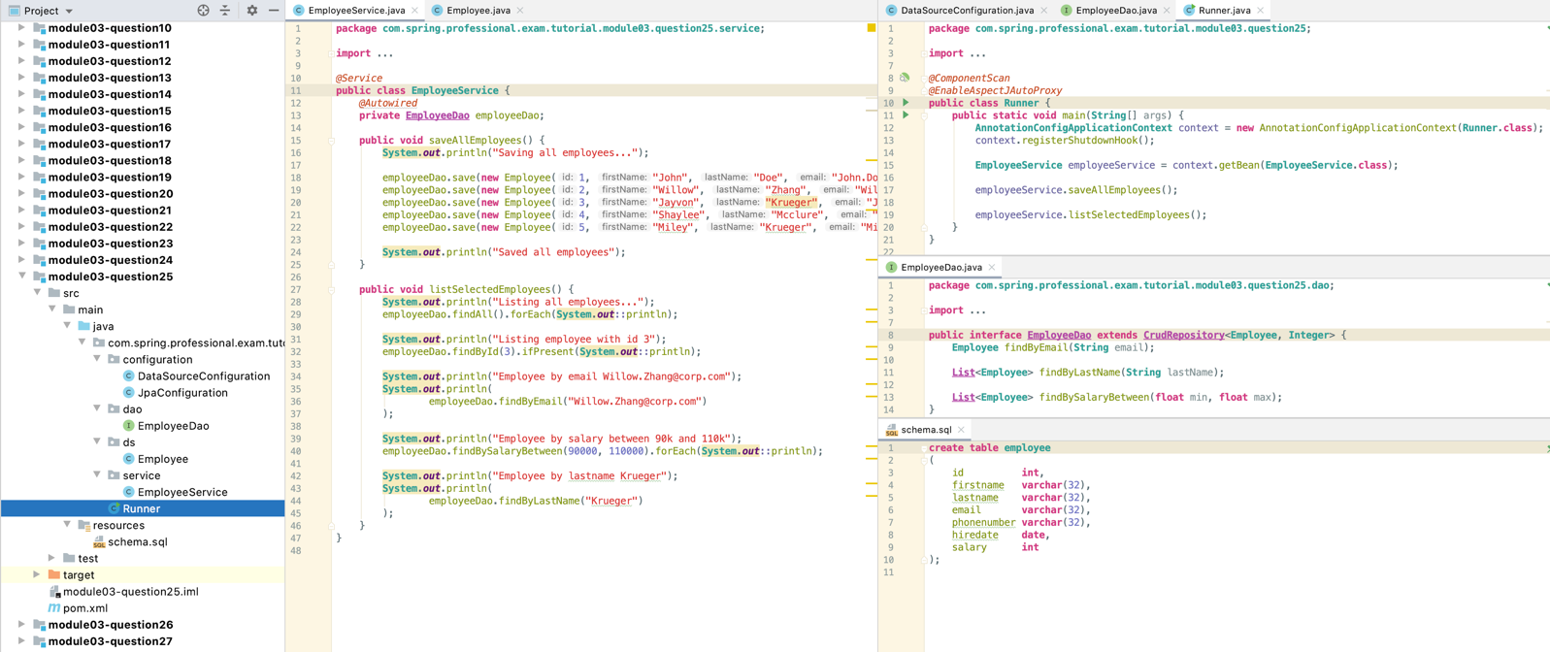

# Question 26 -How do you define a Repository interface? Why is it an interface not a class?

To define Repository interface, you need to follow those steps:

* Create Java Interface that extends one of: Repository, CrudRepository, PagingAndSortingRepository, JpaRepository
* Create class with @Entityannotation
* Inside @Entity class, create a simple primary key annotated with @Id annotation or create class that will represent complex key annotated with @EmbeddedId annotation at field level and @Embeddable at key class definition level
* Use @EnableJpaRepositories to point out package to scan for Repositories

Repository interface is an interface, not a class for Spring Data to be able to use JDK Dynamic Proxy to intercept all calls to repository and also to allow creation of custom base repositories for every Dao based on SimpleJpaRepository configured at @EnableJpaRepositories level.

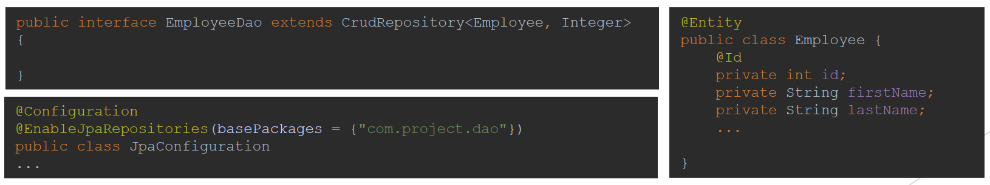

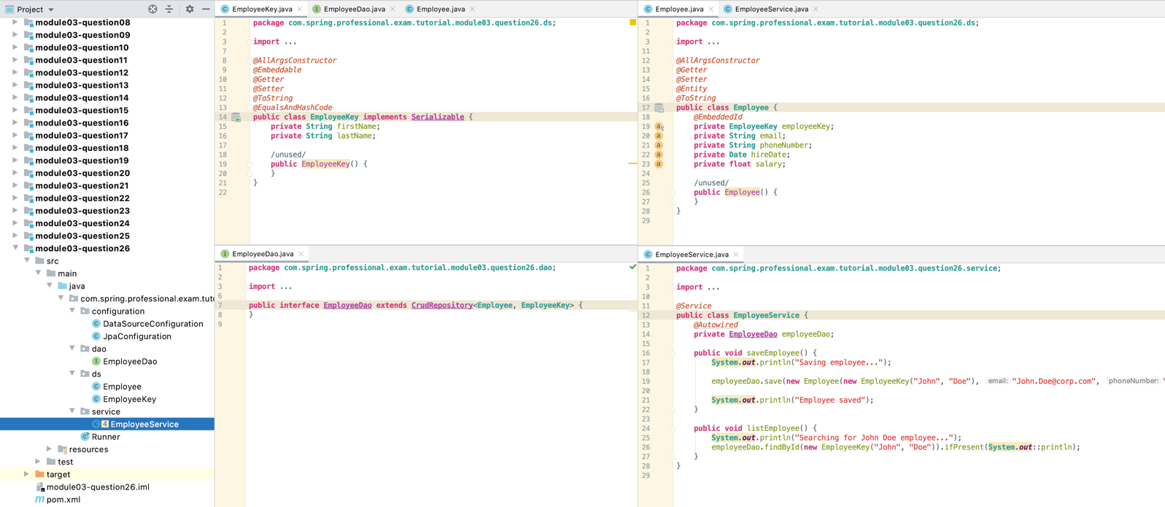

# Question 27-What is the naming convention for finder methods in a Repository interface?

* find *[limit]* By *[property/properties expression] [comparison] [ordering operator]*
* *limit*–result of the query can be limited by usage of first/top keyword
* findFirst10ByLastname
* findFirstByOrderByLastnameAsc
* findTop3ByLastname
* findTopByOrderByAgeDesc

*property/properties expression* –result will be filtered based on property of entity, multiple properties can be used with usage of And, Or keyword

* findByLastnameAndFirstname
* findByLastnameOrFirstname
* findByFirstname

find[limit] By [property/properties expression] [comparison] [ordering operator]

comparison–comparison mode can be specified after specifying property used for filtering

* findByFirstnameIs
* findByFirstnameEquals
* findByStartDateBetween
* findByAgeLessThan,findByAgeLessThanEqual
* findByAgeGreaterThan,findByAgeGreaterThanEqual
* findByStartDateBefore, findByStartDateAfter
* findByAgeIsNull, findByAgeIsNotNull
* findByFirstnameLike, findByFirstnameNotLike
* findByFirstnameStartingWith, findByFirstnameEndingWith
* findByFirstnameContaining
* findByLastnameNot
* findByAgeIn(Collection<Age> ages), findByAgeNotIn(Collection<Age> ages)
* findByActiveTrue,findByActiveFalse
* findByFirstnameIgnoreCase

find*[limit]* By *[property/properties expression] [comparison] [ordering operator]*

*ordering operator*–optionally you can specify ordering operator at the end of method name

* findByLastnameOrderByFirstnameAsc
* findByLastnameOrderByFirstnameDesc

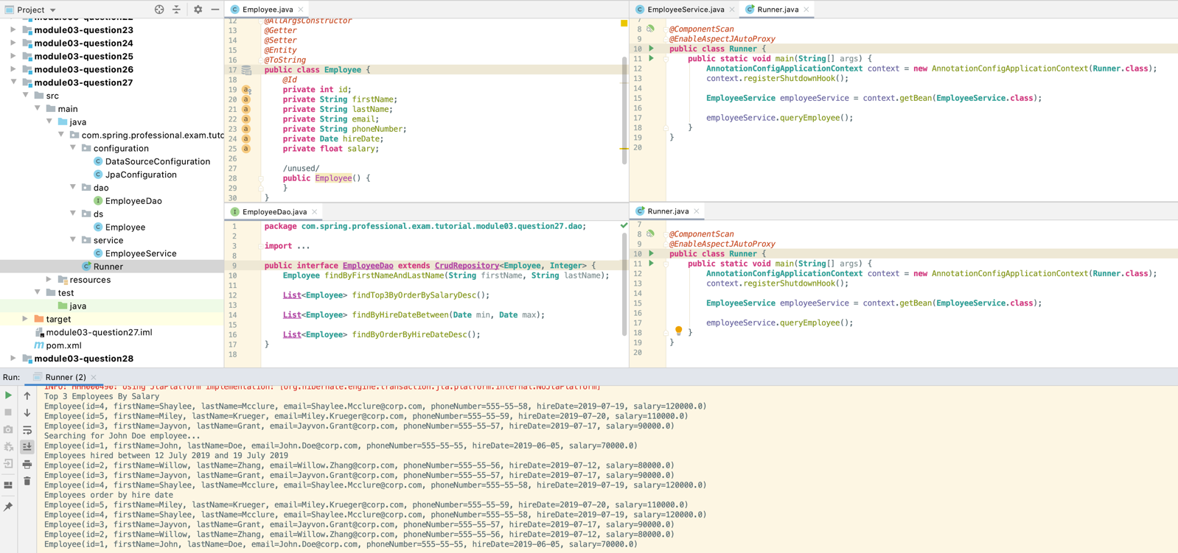

# Question 28-How are Spring Data repositories implemented by Spring at runtime?

Spring Repositories are implemented at runtime by SimpleJpaRepository by default.

When application context is starting up, Spring will scan for all classes annotated with @Configuration. When @Configuration class with @EnableJpaRepositories will be detected, JpaRepositoriesRegistrar with JpaRepositoryConfigExtension will be used to create beans for repositories in packages pointed out by basePackages field in @EnableJpaRepositories. JpaRepositoryFactoryBean will use JpaRepositoryFactory to create beans based on bean definitions and by default will create instance of SimpleJpaRepository class for each Repository interface.

Class used for implementation of Repository interface can be customized on:

* Global level,byusing repositoryBaseClass field from @EnableJpaRepositories annotation
* Single Dao/Repository by creating separate interface and Impl class for behaviour that you want to customize

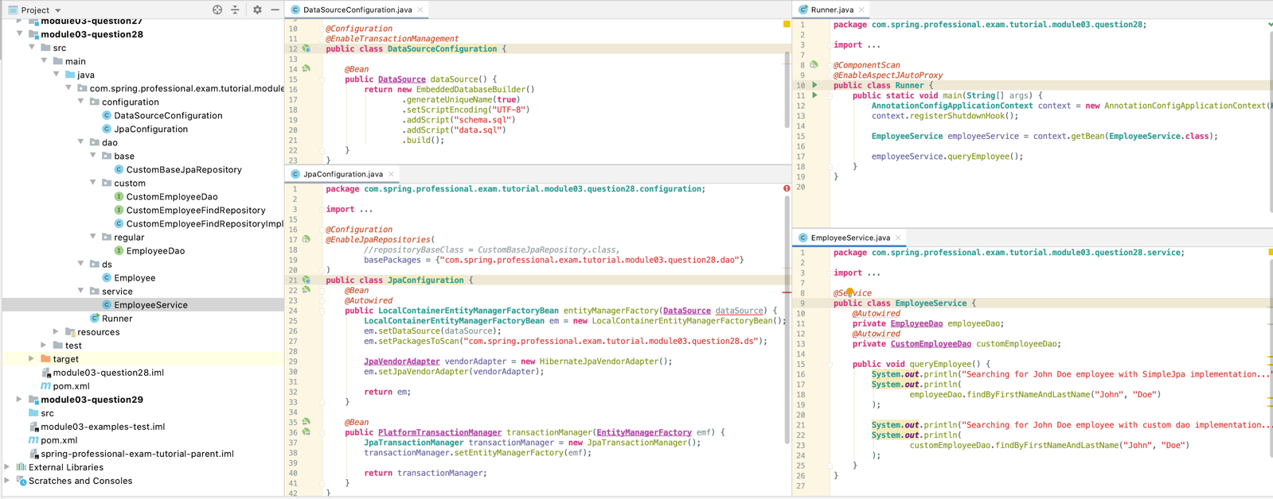

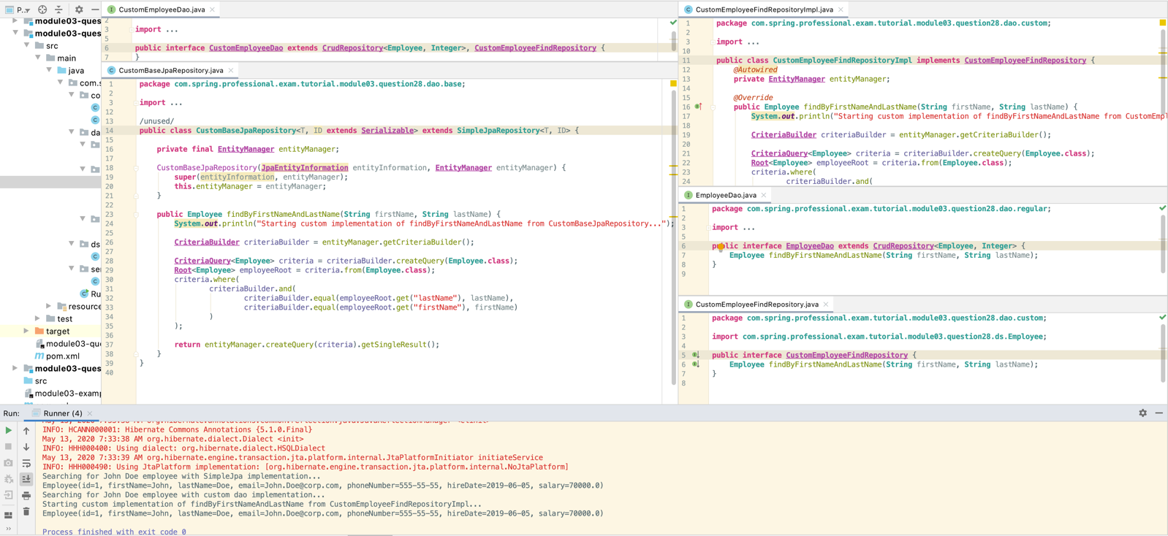

# Question 29 – What is @Query used for?

@Query annotation can be used on top of Repository method, and with it you can specify query that should be used by JPA. When declaring one on top of finder method, specified query will be used, instead of generating one automatically based on finder method name.

Using @Query annotation allows you to achieve more control and flexibility of the JPA query that will be executed.

**public interface EmployeeDao extends CrudRepository**<**Employee**, **Integer**> {  
 *@Query*("select e from **Employee** e where e.firstName = ?1 and e.lastName = ?2")  
 **Employee** findByFirstNameAndLastName(**String** firstName, **String** lastName);  
}

